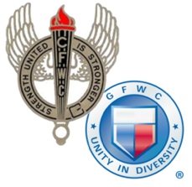
Woodland Hills Woman’s Club
P. O. Box 105
Woodland Hills, CA 91365

Federal ID #95-6096790

Dear Contributor:

On behalf of the Woodland Hills Woman’s Club, please accept our thanks for your support and generous donation.

This club is a 501(c)3 nonprofit organization, therefore, this donation is tax deductible to the fullest amount allowed by law.

The proceeds from this event will continue to support many local charities in the greater San Fernando Valley.

DONOR:___________________________________________________________________________

ADDRESS:__________________________________________________________________________

CITY:_____________________________________________STATE:___________ZIP:____________

LIST BELOW YOUR ITEMS DONATED FOR IRS RECORDS:

(If more space needed, please use reverse side.)

TOTAL VALUE (ESTIMATED BY DONNOR) $_________________________________

DATE:______________________________

RECEIVED BY:______________________________________________________________________
Woodland Hills Woman’s Club Representative

Affiliations: General Federation of Women’s Clubs and California Federation of Women’s Clubs

