

 MARCH 2023 NEWSLETTER

STATED MEETINGS, September thru June / 3rd Thursdays @ 10AM
WHWC President, Rachel Garcia rachelwhwc@gmail.com
Newsletter Publisher, Chris Wright Roper thekrazykatlady@gmail.com
---------------------------------------------------------------
MARCH MONTHLY MEETING

Let’s all WEAR GREEN!
Thursday, March 16, 2023 @ 10AM
WOODLAND HILLS COUNTRY CLUB
21150 Dumetz Rd., Woodland Hills, CA 91364
Cost $36 - Check, Venmo, Credit Card or Cash (If paying with cash, please bring exact bills)
*******
IF YOU HAVE A “STANDING RESER”, ONLY A DECLINATION IS NECESSSARY:
RSVP your attendance (yes or no!) to: CHRIS WRIGHT ROPER
Landline: 805/791-3915 thekrazykatlady@gmail.com

STAY TUNED FOR “SPEAKER” INFORMATION!
WATCH FOR MEETING FLYER . . . SOON !!!

MENU: Sit-down, plated luncheon of Corned Beef with Cabbage, Potatoes & Carrots, Warm Rolls with Butter. Chef’s Choice of Dessert


REMINDER, MEMBERSHIP DUES BECOME DELINQUENT ON MARCH 31. To avoid a $10 late fee . . . and, if you want to be first to pay your dues, send off your $60 check to our Glenn Ellis, 5526 Mason St., Woodland Hills CA 91367 (or, Venmo).
If you know you’re responsible for two lunches because of non-attendance at meetings, include $36 per lunch = $72 (See Page 34 of 2022-2023 Year Book)
AND, if you’d like the monthly NEWSLETTER snail-mailed to you, include + $25

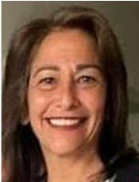
President’s Message – Rachel Garcia
 “Baby, it's cold outside!”
It's been a mighty cold winter . . . chills to the bone!! Yet we have persisted to accomplish our tasks at hand. With the year rushing into March so quickly, the cold air will be replaced with our, oh! so familiar, cool spring evenings! Our membership has been through transition, and we are in full momentum with the chairs in place and programs being scheduled. I do believe we are achieving goals gloriously. For every situation, there is a solution! I would like to extend a special thank you to our Board. We have worked through and continue to see the gains and profit for our community!
Without our members and community, we would not have a mission. Let's continue to focus on solutions to help our community overcome the challenges life serves up. On that note, we do have some fundraising events you will be reading about in Freddie’s section! The program chairs are in place . . . there will be tasks to complete! Let’s get to work! We can make a difference and leave a Legacy of Learning and Loving!
See everyone at the District Event. Keep Warm!

1st VP, Dean of Chairmen – Arlene Bell
MARCH . . . Let us SPRING into Action!
March is the month for the spring season -- warmer weather and flowers. It is referred to as the season of REBIRTH, AND REJUVINATION. March is also the month we celebrate women’s contributions in helping to make the world, our country, and our community a more inclusive place. It’s also a great time to celebrate women who make a difference in our lives . . . your mom, grandmothers, sisters, and girlfriends!
The women listed below are members of the Woodland Hills Woman’s Club who have volunteered to be Chairman, or be on committees. A BIG THANK YOU TO:
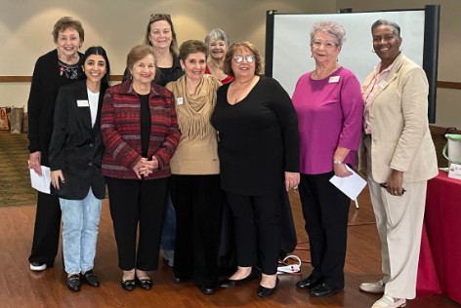
Vicki Harris: Sunshine CHAIR
Ruthanne Thompson: Health & Wellness - Painted Turtle
Freddie Ferguson: Conservation
Millicent Callahan: Arts & Culture - Music
Nona Mason: Health and Wellness – West Valley Food Pantry
Jasmine Kohanim: Advocates for Children
Betty Paravato: Advocates for Children
Arlene Bell: Health & Wellness - C.A.T.S. - Civic Engagement & Outreach – Foundation for Women
Warriors
Karen Lakin: Education and Libraries - Sponsorship
Liz Strother: Education and Libraries - Sponsorship
MaryRose Maraglia: Civic Engagement and Outreach - Fisher House - Health & Wellness – Domestic
Violence
 WE NEED EVERYONE’S HELP!
WE HAVE ALREADY STARTED GETTING DONATIONS FOR THE WINE PULL THAT WILL BE PART OF OUR AUGUST “SUMMERTIME TEA”. An alternative option to donating an actual bottle of wine is to make a monetary donation! You can give our Treasurer a $15 check so Irene Deak can make a purchase on your behalf. CHECK or CASH to: Glenn Ellis. We need a total of 60 bottles of wine. The money needs to be collected before the club goes dark in June.
2nd VP, Membership – Stephanie Knizek
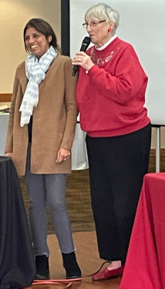
STEPH WELCOMES, NEW MEMBER . . . PERIN LAL
PERIN LAL Perin moved to America from her home country, India, at the age of 18. After
4652 Overland Dr. College, she worked as an architect until the age of 33. She then started her own
818-298-7900 business, COMPUTERWISEKIDS. She has contracts with 28 LAUSD schools to
West Hills CA 91304 provide help and resources, teaching children all the ins and outs of computer
emailperin@aol.com technology. Her husband works with her in the business. They are empty nesters with both of their boys in college. Perin is excited to participate in the
life of our Club. She hopes she can be of help to any Club member who needs help with the world of
technology. She is a wonderful addition to our Club, so please make it a priority to get to know her and
make her feel welcome.

3rd VP, Fundraising – Freddie Ferguson
As we are passing the winter months, we are making our way into the exciting times working together on fundraising!

Our Lunch Bunch group gathered at Los Toro in Chatsworth, and we made a surplus of $71.08 while enjoying a great lunch!

In April, Chris Roper will be heading our effortless “BAKE-LESS BAKE SALE”. Always a successful non-event!

May we will possibly have BUNCO at St Bernadine Church’s Parish Hall.

Of course, our star event, the SUMMERTIME TEA will be held on Saturday, August 5. All members are encouraged to participate in any of the many tasks to make our event successful.
Arlene Bell is heading up a new “WINE PULL”. We are asking all members to donate of at least one bottle of wine with a retail-value of $25. Or, if wine-shopping is not your thing, you may opt for a cash donation of $15 or more (checks to Arlene Bell). Arlene or Irene Deak will make the purchase for you!

The updated “Generic Solicitation Letter” was emailed to membership. Please print copies and pass them out to your hairdresser, your butcher, your baker and anyone else! Request gift cards or product asking that we can put in our “Silent Auction” baskets. And, speaking of baskets . . . we need a lot of filler-items for our Silent Auction baskets. So, please check your re-gifting closets and gather up those new (or, like-new) items you might have received and have no use for! We also need a lot of packing paper brown wrapping paper, bubble wrap and raffia for filler in the baskets. Please donate your medium- and large-sized baskets! You may bring Silent Auction items to meetings or keep them to bring to our basket-making “party” . . . the last week in July at St Bernadine's.
WE NEED TABLE DECORATORS AND HELPERS!! This year, we will decorating 25 tables and we are still short about ten volunteers! Use your imagination! We will provide a table set-up requirements.

LEGISLATION – Rosadel McClure, Legislation Chair
As stated in the Bylaws, “The object of this Club shall be the promotion of education, research, social welfare, and betterment of the community.” We are members because we care about people and our community. As a member of The Woodland Hills Woman’s Club, you are also part of the State, CFWC, and the National GFWC organization. The combined voices of our members are influential in determining the laws that care for people and our community. Our legal representatives especially listen to our voices.
GFWC’s LEGISLATIVE ACTION CENTER makes sending letters to our legal representatives SO easy. With just one touch of a button, you can send letters on the pending bills to your elected officials. I was disappointed to see only a few members have signed up to take advantage of this opportunity to be heard.
THE LEGISLATIVE ACTION CENTER gives full details and the history of pending bills. The letters sent are well- written and intelligently presented. There is also an opportunity to add your personnel comments.
The 118th Congress is now back in session, and there couldn’t be a better time to SIGN UP FOR THE LEGISLATIVE ACTION CENTER ON GFWC.org. Your letters are so important and each one is counted. Your elected representatives rely on this information, especially when seeking your vote.
THE POWER OF WOMEN IS THROUGH A UNITED VOICE.

VETERANS AFFAIRS - Rosadel McClure, Veterans Chair
I’m delighted that two of our members are now leading two veteran’s projects. Arlene Bell is the Chairman of The Foundation for Women Warriors and MaryRose Miraglia is the chairman of The Fisher House project. Each is very enthusiastic and have a special interest in their project. The ten members who volunteered for Operation Gratitude in February brought with them donations for over 400 blank and greeting cards, six hand knitted
scarves, playing cards and games as well as a large box of folded comics. Chris Roper delivered a box of your donated paperback books to For The Troops in Simi Valley. Thank you, Chris and all the members who
donated books. Thanks also to Rachel for helping carry your donations to my car and volunteering to deliver donations to Operation Gratitude.

PARLIAMENTARY MOMENT - Rosadel McClure
An amendment is offered while a motion is on the floor. To offer an amendment, a member must be first recognized by the presiding officer. Having obtained the floor, she introduces the amendment by saying: I move to amend by. . . . , stating how and where she wishes to change the motion. Another member seconds the motion. Then the amendment is stated by the chair, debated by the assembly, and may be possibly amended itself. When brought to a vote, it requires a majority; and if adopted, the amendment becomes part of the main
motion. Then, the main motion incorporating the amendment is stated by the chair and voted on by the assembly.

THURSDAY, MARCH 9 @ 11:30AM
Our Club will be hosting a potluck luncheon for our local firefighters at Fire Station 105
Fire Station 105 -- 6345 Fallbrook Ave., Woodland Hills (South of Victory Blvd.)
The Club will cover the cost of the corned beef . . . we ask that members who can join us for lunch bring the side dishes and desserts. We all sit around their long table & have a very enjoyable time lunching with these wonderful heroes!

If you did not sign up at the February meeting and would like to be part of this grand day, let CHRIS ROPER know quickly. Landline 805/791-3915 Cell/text 310/560-9171 thekrazykatlady@gmail.com
(If you cannot stay for lunch, that's OK, too. You can still drop off a dish!)

GOLFERS Chair, Millicent Callahan
Golf Group will meet Friday, March 31 at 2:00 p.m. for a 9-hole round. The
meeting place is the same and the address is listed below.

Van Nuys Golf Course
6550 Odessa Ave,
Los Angeles, CA 91406-6517

LUNCH BUNCH – Cheryl Ayers, Chair
Our March LUNCH BUNCH gathering will be part of DISTRICT’s “Arts & Craft Festival” - RSVP your attendance to Cheryl Ayers CELL/Text: 818/317-2685 cheryllcornell@yahoo.com
Thursday, March 23 @ 10AM (Lunch will be served at “lunchtime” . . . during the event)
CANOGA PARK WOMEN’S CLUB Clubhouse
7401 Jordan Avenue, Canoga Park – corner of Valerio St.)
LUNCH $15 (Pay at the door). If paying by check, payable: Sierra-Cahuenga District
NOTE: The lunch boxes are being prepared by OUR CLUB! If you can help on Wednesday and/or Thursday, please contact Betty Paravato Cell 818/625-0545 bparavato@socal.rr.com

A GREAT TIME WAS HAD BY THOSE WHO STUFFED 83 "Battalion Bears" at OPERATION GRATITUDE on February 23. We had such a good time, we’ll probably be going back! JOIN US, NEXT TIME!
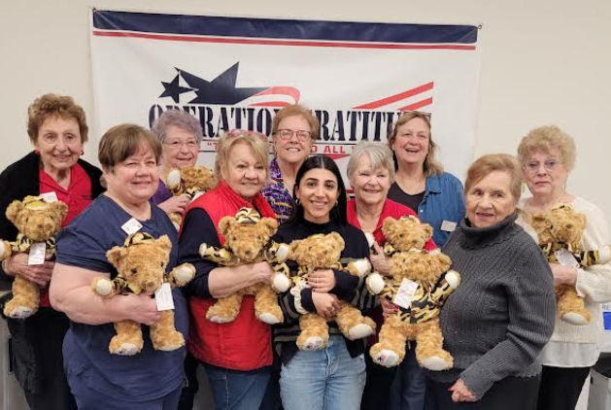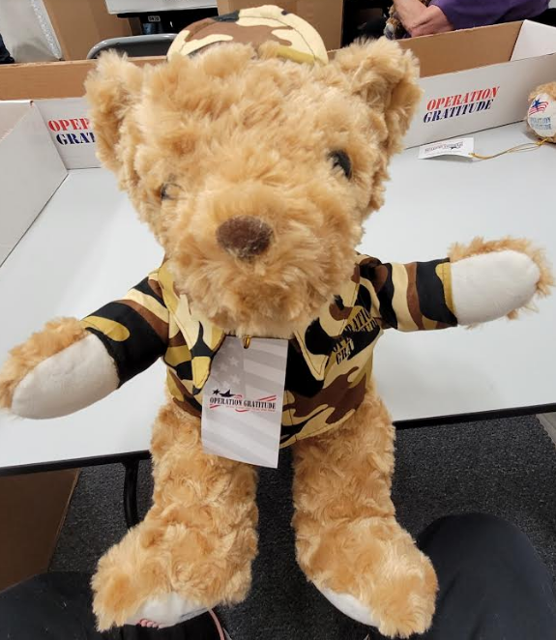

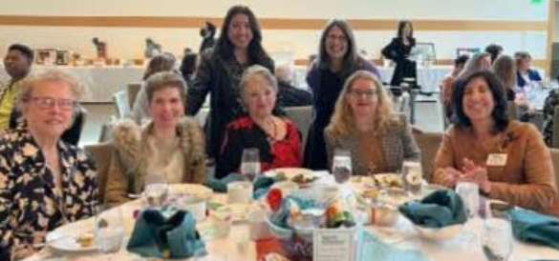 MAPS Charities Luncheon
Attending the MAPS Charities Fundraiser Luncheon on February 17 were WHWC members, Chris Roper, Arlene Bell, Betty Paravato and Janet Morris (at another table, MaryRose Miraglia (not pictured). MAPS (Mission to Assist and Provide for Seniors) is one of WHWC’s philanthropic focuses!

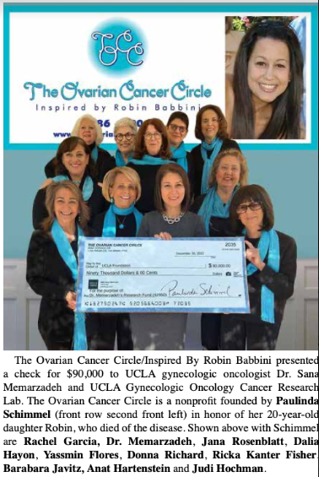
Note . . . our Club’s President, Rachel Garcia, is pictured as part of this presentation from OVARIAN CANCER CIRCLE to UCLA’s gynecologic oncologist Dr. Sana Memarzadeh.

HELPERS ARE NEEDED – District “Arts & Craft Festival”
Members are needed to help make and prepare the lunch for the District “Arts & Craft Festival” on March 22 and/or March 23. Please call Betty Paravato at 818-625-0545 if you can help either or both days. Times would be from 9AM until 1’ish. (NOTE: We encourage all “LUNCH BUNCHers” to attend the luncheon on March 23 @ $15).

DISTRICT FOOTBALL BOOK – WHWC Winners!
Congratulations to our WHWC members whose football books were winners of the playoffs games! Each received a $50 check in the mail. While we had a lot of other winners from the books we sold, these were the ones from our club: Rachel Garcia, Kay Winnert, Rosadel McClure, Laura Dash, Freddie Ferguson, Chris Roper’s sister (Kathy), Marsha LaRusso’s husband (Rich), and Betty Paravato’s husband (Marty), son (Paul) and Grandson (Nathan). Sorry if you bought a book and did not win -- but try again next year. The Sierra-Cahuenga District thanks all who participated in this their only annual fundraising event!
 SCHOLARSHIPS FOR HIGH SCHOOL SENIORS
Do you know of a high school senior in high school or a grandchild who’s a senior? The Sierra-Cahuenga District awards scholarships to seniors living in our district. Applications can be obtained from our District President, Betty Paravato or from District’s Corresponding Secretary, Jenny Metz at 818-599-2398.

 WEST VALLEY PLAYHOUSE
Let's all enjoy an evening or matinee at our local theater while supporting one of our Club's charities, the West Hills Optimist Club! The West Valley Playhouse is performing Agatha Christie’s “SPIDER’S WEB”!
Tickets ($32, payable “West Hills Optimist”) for March 11 (8PM) or March 12 (SOLD OUT) performance are available through our WHWC member, Kathy Willets Cell 818/970-7200 willets.kathy@gmail.com
CHILDREN IN FOSTER CARE 
Did you know that a child in Foster Care, when going to a new foster home, brings all their belongings in a black garbage bag? Do you have old rolling suitcases or smaller suitcases that you no longer use? Bring them to a meeting and Betty Paravato will take them to the Foster Care Facility in Camarillo. A little joy in a child’s life is having something that belongs to them. If you can’t get to a meeting, call Betty and she’ll arrange for pick-up.

CLUB CRAFTERS
The following people expressed an interest in belonging to the craft section of our club and we would like to get it going again: Betty Paravato, Vicki Harris, Freddie Ferguson, Kathy Willets, MaryRose Miraglia, Irene Deak, Barbara Hogan, Cheryl Sullivan, Roberta Marlowe, Jean Wiedmeier, and Cary Bird. Right now, we would need to meet and decide what we’d like to make, how much we are willing to spend on a craft, what crafts we are going to do, and where we will hold the workshops. So that we can move forward, please contact Betty Paravato to confirm being part of the group (MORE ARE WELCOME!). Betty is not the chairman (we don’t have one) but until we all meet and figure out what we are doing, nothing is going to happen. Let’s start having fun doing crafts together. Call Betty at 818/625-0545.

DECORATORS NEEDED – State Convention
WHWC is responsible for the centerpieces at State Convention (May 17) and we need members to help get them together and fixed up. It will mostly involve sorting books into stacks and tying them up with ribbons to put on the tables. Any help would be greatly appreciated, and I can work around your time. Call Betty at 818/625-0545.

HEALTHY HEART, HEALTHY LIFE
Did you know that heart disease and heart attacks are the #1 cause of death for women in America? The American Heart Association recommends the following types of foods to keep your heart and health strong for seniors:
- Eat: Leafy Green Vegetables, Whole Grains, Berries and Legumes (beans).
- Reduce Salt and Sodium (never use a saltshaker to add salt to your food).
- Choose the right kind of fats like Olive or Canola Oils – don’t use butter or lard.
- Have treats in moderation (Dark Chocolate – and Red Wines are good and are better for you.)

 WE GOT MAIL!
An email from SAVING INNOCENSE thanking us for generous 2022 monetary donations/

DATES TO KEEP ON YOUR RADAR!

EVERY Tuesday @ 10AM til 11AM - READING CLUB (Via Z00M)
EVERY Tuesday @ 11AM til 11:30AM - WRITING GROUP -Topic: Journaling (Via Z00M)
EVERY Wednesday @ 8AM-9AM (except the 1st Wednesday = WHWC Board Meeting)
8AM til 9AM - WALKING WOMEN WEDNESDAYS at Orcutt Ranch - 23600 Roscoe Blvd., West hills

Thursday, MARCH 9 @ 11:30AM – FIREMEN’S LUNCH at Fire Station 105

Wednesday, MARCH 15 @ 7:30AM – Angels Way Maternity Home 5th Annual Breakfast @ WHCC

Thursday, MARCH 16 @ 10AM – WHWC MONTHLY MEETING @ Woodland Hills Country Club

Saturday, MARCH 18 @ 10:30AM – Granada Hills Woman’s Club Fashion Show Luncheon @ GHWC Clubhouse

Wednesday & Thursday, MARCH 22 & 23 – District’s “ARTS & CRAFT FESTIVAL” @ CPWC Clubhouse (LUNCH BUNCH will gather at the event on Thursday. See Flyer)

Friday, APRIL 14 – SIERRA CAHUENGA DISTRICT CONVENTION @ AirTel Hotel, Van Nuys

APRIL MAILING - Expect to receive the WORK-LESS, "BAKE-LESS BAKE SALE" -- WATCH YOUR MAILBOX !!!

OUR CLUB’S “SUMMERTIME TEA” WILL BE HELD SAT., AUG. 5 !!!
Ask your friends & relatives to SAVE THE DATE !!!!

