

 FEBRUARY 2023 NEWSLETTER
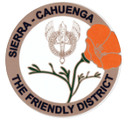
STATED MEETINGS, September thru June / 3rd Thursdays @ 10AM
WHWC President, Rachel Garcia rachelwhwc@gmail.com
Newsletter Publisher, Chris Wright Roper thekrazykatlady@gmail.com
---------------------------------------------------------------
FEBRUARY MONTHLY MEETING
Thursday, February 16, 2023 @ 10AM
WOODLAND HILLS COUNTRY CLUB
21150 Dumetz Rd., Woodland Hills, CA 91364
Cost $36 - Check, Venmo, Credit Card or Cash (If paying with cash, please bring exact currency)
*******
IF YOU HAVE A “STANDING RESER”, ONLY A DECLINATION IS NECESSSARY:
FOR THE FEBRUARY MEETING, RSVP your attendance (yes or no!) to:
BETTY PARAVATO Landline: 818/716-6299 paravato@socal.rr.com

******
Speaker - Amanda Robin, Ph.C.
COMPASS FOR YOUTH – FOSTERING POTENTIAL
MISSION The mission of Compass for Youth is to coordinate long-term solutions for California’s former and current foster care youth by administering support for obstacles in the university education pipeline.
VISION We will achieve this vision by providing one-on-one outreach and prevention methods to high school-aged foster care and former foster care youth. We are dedicated to enhancing the lives of youth by cultivating a vibrant community resource that connects youth with the skills, partnerships, and services they need to secure a brighter future- through the upward mobility of a university education.
BACKGROUND As youth who have experienced life in inner cities, in foster care, and on the streets, our founders know the power education has to change the trajectory of one’s life. After graduating from the University of California, Los Angeles (UCLA), Compass’ founders entered careers in the education and nonprofit fields. We are passionate about offering a similar educational opportunity for those who could benefit the most: foster care youth.
MENU: WRAP AND SALAD BAR- SALAD BAR, ASSORTED WRAPS (TURKEY, CHICKEN SALAD, AND TUNA SALAD), CROCK OF SOUP, CHEF’S CHOICE OF DESSERT
President’s Message – Rachel Garcia

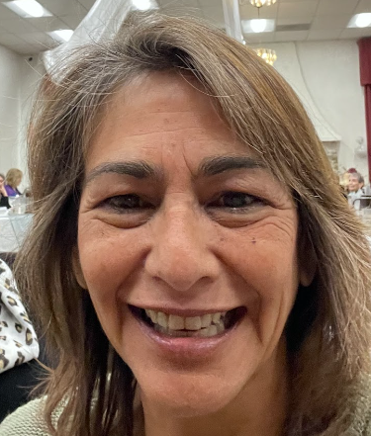

We are entering the season of LOVE, February!
Yes, we are feeling the Love! A number of us visited C.A.T.S. (Center for Assault Treatment Services) and were touched by the care and professionalism of the facility. The facility staff has brought privacy to a situation where “Love” was forgotten. They strive to bring a feeling of safety and have put together a process that was painful and drawn out, to a facility where everything can be done with respect and care in one place. When families flee and statements have to be made, the siblings and family members have a space to be comfortable in a rather than an uncomfortable situation.
They were grateful to receive approximately 8 bags of clothes and our Club’s donation of $500 -- plus, one of our members donated $100!
Thank you ladies! Next month, join us when we tour Angels Way. Details will be emailed.
Keep an eye out for Rosadel McClure’s upcoming Veterans events. Last month, Rosadel brought Valentine's cards to our General Meeting, we all wrote them out and mailed them to our troops! Operation Gratitude needs “Teddy bear STUFFERS”. Keep an eye out for the date and time, and Join us stuffing the sweet bears for the children that are letting their family members serve our country! It's a little something for them to cuddle in remembrance of their loved one! Here’s to a prosperous, love-filled February! Happy Valentine’s Day

P.S. Monday, January 16, was fabulous day at Canoga Park Women’s Club. District President, Betty Paravato, led the District meeting. It was a nice afternoon with lots going on this upcoming month! Read your newsletter and QuickBytes for all the dates and times of upcoming events!

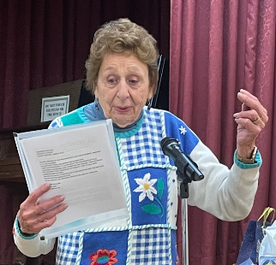 District’s Legislation & Public Policy Chair, Rosadel McClure reporting!

1st VP, Dean of Chairmen – Arlene Bell

FEBRURY HIGHLIGHTS
We are now into the second month of the New Year. We can now breathe easier holidays are over and maybe even some of those New Year’s resolutions. The club is getting involved in touring some of the projects that we donate not only money, but clothing, and volunteer time. It is so gratifying to see our donations at work.
February Highlights in U.S. Women’s History:
February 27, 1922: US Supreme Court upholds the 19 th Amendment to the Constitution which guarantees women the right to vote.
February 15, 1921: The Suffrage Monument, depicting Susan B. Anthony,
Elizabeth Cady Stanton, and Lucretia Mott, and carved by Adelaide Johnson, is dedicated in the Nation’s Capitol. These are just a few of the achievements of great woman in history.

We will be taking another tour this month to one of the projects that we are involved with.
Seeing, be there in person, only cements the energy that the club has to make a difference. A sign-up sheet for our Project Haven Hills will be next, in February.

Please talk to me about a project that you are interested in touring, and I will gladly make the arrangements.

P.S. from Betty Paravato: REPORTING HOURS

Our club needs to have your hours for our year end reports, but there are several ways you can do this. On your calendar or on your phone (however you keep track of things), mark down hours and event each time you do something with the club. Your club meeting counts as 5 hours. If you bring recycling, it counts as 1 hour each. You also count mileage to and from an event. Keep track of money donated to and event or a charity, this counts if it goes through our club treasury, not if you send it directly to the charity. Count anything you do for another club -- like Bingo at the Canoga Park club - but not the money spent there. Doing research for a project or information for the club about a charity. You can make it simple on yourself by just turning in a sheet that lists everything you did for that month, you don’t have to use the club’s hour form if that confuses you. Arlene will bring a sample one to the next meeting. It is easier to turn in hours for the previous month as we haven’t finished the month you are in at the meeting. If you have questions about how much to put down or what you can count, please give Arlene Bell a call.

Another P.S. from Betty Paravato: CHAIRMEN & COMMITTEE
MEMBERS NEEDED!

Think about why you joined the Woodland Hills Woman’s Club. Was it to help out a certain charity, our local community needs, a chance to make new friends, or what? To do any of those things, we need your help in working with charities, finding new projects to support, doing research for charities, things like that. So, if you have a special interest, an area you are really committed to, like environment, education, health and wellness, helping animals, supporting our vets and law enforcement . . . whatever, please volunteer to work on one of these committees or even be the chairman of it. You can’t mess it up, all you can is give it your best – there are no failures in federation, just chances to make things better. Even if you have been a member forever, we still need your help working on projects and guiding new members on what the club does and how it does it. Please think about it. Our bylaws do say every member must be on a committee – which one are you on? Arlene Bell is waiting to hear from you!

3rd VP, Fundraising – Freddie Ferguson

New Year’s greetings, ladies!
The Fundraising committee is looking forward to a fun and profitable year.
Our annual Bake-less Bake Sale, chaired by Chris Roper, will be held in mid-April.
Possible Bunco in late May.
Of course, our star fundraiser, The Summer Tea, will be held on August 5 at St Bernadine's church’s Parish Hall. The cost per person this year will be $80. Tickets are expected to sell-out quickly.
Please be gathering items from your re-gifting closet for basket making. Also, we will be asking for gift cards and donations from our favorite local stores, salons and restaurants.
Please save your gently-used baskets, and basket-fillers, raffia, brown packing paper, and shredded paper, etc. for our basket making days in late July.
With everyone’s participation, we are looking forward to a fun and successful tea!
Thanks to all the ladies who attended our Fundraising Committee meeting after our January General Meeting this past week. God bless you all.

CALIFORNIA WILDLIFE CENTER (CWC) – Glenn Ellis, Chair

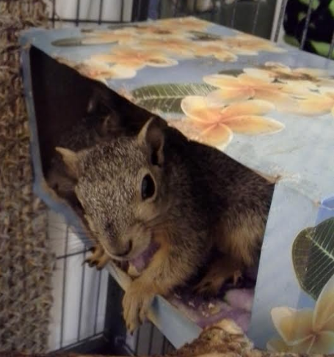

Our Club supports the CALIFORNIA WILDLIFE CENTER with donations from our treasury and hours spent by three of our members, feeding orphan baby squirrels and raccoons.
The CALIFORNIA WILDLIFE CENTER is a wildlife hospital with a full-time vet and vet techs. They care for all kinds of wildlife from sea lions to humming birds, bobcats to squirrels, deer to skunks, etc. Most of the animals they care for are injured or ill, but some are just orphans too young to survive on their own. 4,100 animals from 161 species came through CWC’s doors in the last 12 months.
Squirrels were the most frequent species admitted to CWC last year – 448 of them, most of whom came in as orphans and were first cared for in Glenn’s home (where they sucked formula from a syringe) with the help of volunteers, two of whom are WHWC members, Arlene Bell and Vicki Harris. Any day now, the first newborn squirrels of the season will be found by someone walking their dog, gardening, or just sitting outside. And the baby(s) will be brought into care, treated for any injury, raised and ultimately released back into the wild.

LEGISLATION – Rosadel McClure, Legislation Chair

In 2022, the California legislature passed nearly 1,200 bills ---and 1,000 became law with gov. Gavin Newsom’s signature. Along with 2023 come many changes to laws governing traffic, official holidays, and equality for women. Here are a few that are of special interest to us.

Be especially careful when driving!
Jaywalking is now legal! It is only an offense to cross the street at a non-designated area when “reasonably careful person would realize there is an immediate danger of a collision.” You are responsible to stop when a person is crossing in the middle of the block!

Watch out for Bicycles!
Previously, California law required vehicles to maintain 3 feet distance when passing bicycles headed in the same direction, but a new law will now require vehicles to move into another lane “with due regard for safety and traffic conditions, if practicable and not prohibited by law.” This is like the requirement that motor vehicles move over a lane to pass a stationary emergency vehicle.

Californians 70 and older can no longer renew their licenses online! Their license must be renewed in person at a DMV office even if their notice states otherwise.

A new law is designed to end the “pink tax” on products marketed to women in California. With this law stores will be banned from charging a different price based on gender. Ending the “pink” tax is another step in the cause of gender equity.

Governor Newson signed several new holidays into law including:
Genocide Remembrance Day (April 24), Juneteenth (June 19). Lunar new year (on the second or third new moon following the winter solstice) and Native American day (fourth Friday of September.)

VETERANS AFFAIRS - Rosadel McClure, Veterans Chair
As part of the Valentines for Veterans program, the WOODLAND HILLS WOMAN’S CLUB members signed Valentines at the January Meeting. Because of your kindness fifty (50) VA veterans will be remembered with a Valentine.

DONATIONS NEEDED:
The FOUNDATION FOR WOMEN WARRIORS now has a warehouse for a Clothes Closet where the women can pick out needed clothes for interviews and work. When you are cleaning out your closet, please save any new or slightly used clothes for The FOUNDATION FOR WOMEN WARRIORS. They can also use children’s clothing.

The VA needs warm used clothing for the homeless veterans, especially jackets and coats. Both men and women need the clothing to keep warm. New underwear and socks are always in demand.

You can bring your donations to the February meeting or drop them on at my porch at any time.

LUNCH BUNCH – Cheryl Ayers, Chair

A WONDERFUL WAY TO GET TO KNOW MEMBERS IN A SMALL SETTING! JOIN THE MONTHLY LUNCH BUNCH . . . 4th Thursday @ 11:30AM. Questions or Reservations - Contact Cheryl - CELL/TEXT: 818/317-2685 cheryllcornell@yahoo.com

ANGEL’S WAY BREAKFAST – Betty Paravato

I don’t know if you remember when we used to go to the ANGEL’S WAY Breakfast at the Woodland Hills Country Club or not, but they are back to having them again as their major fundraiser. It will be held on Wednesday, March 15 from 7:30AM to 9:00AM, and you are all invited to join us there . . . BUT I need to RSVP to them for seating by February 15. This is a wonderful charity that we support. Angel’s Way houses pregnant ladies who have no one and nowhere else to turn to. They keep them until the baby is born and then as long as it takes to get settled into permanent housing. While at the house, they are trained on proper parenting and job training to secure a job after the baby is born. Please let me know if you want to join me there, there is no charge for you to attend . . . our club has sponsored the table. Right now, I have Arlene, Chris, Ruthanne, Rosadel and me attending – We’d love to have more join us. RSVP QUICKLY: Betty: Cell/text 818/625-0545 bparavato@socal.rr.com

A REFRESHER COURSE from Member, MYRA FISHER

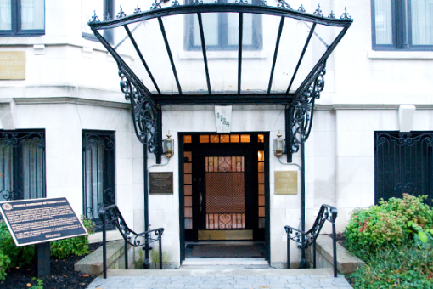 GFWC’s headquarters are in Washington, D.C.

I thought that with so many new members these past few years, it might be time to share information about our national organization.

We are very fortunate to be a member of one of the oldest women’s organizations – General Federation of Women’s Clubs (GFWC), an international organization of community-based volunteer women’s clubs whose members are dedicated to community service. I’m sure this has been quite obvious when at our meetings during the Dean’s portion of the meetings, chairmen are making motions to donate to support other nonprofit organizations in their endeavors.

GFWC’s headquarters are in Washington, D.C. where many other national organizations have their headquarters. I consider this to be a feather in our cap. And to add to that, the headquarters became a National Historic Landmark in 1991. It was designated as such by the National Park Service and the Secretary of the Interior in recognition of its “national significance in commemorating the history of the United States of America.”

How did all this happen, you ask? It was built in1875 as a private residence by Rear Admiral William Radford upon his retirement from the U.S. Navy. The four story brick and stone mansion is located at 1734 N Street, NW, not too far from the Metro red line Dupont Circle stop. In 1895 popular subscription raised funds to buy the house as a gift to the distinguished soldier General Nelson A. Miles in recognition of his military service.

The house, then known as the Nelson A. Miles Mansion, was later owned by Mr. and Mrs. John Jay White who remodeled it into a modern residence. In 1922 Mr. White agreed to sell the house to GFWC for $70,000. When GFWC agreed to buy the house there was no money to pay for it. However, GFWCs’ leaders raised funds for the purchase when they presented the details at their 1922 convention in Chautauqua, New York. Enough money was pledged to complete paying for the building and begin necessary changes. They redecorated for staff offices and an apartment where the GFWC president lives during her two-year term of office.

It is a beautiful building with many rooms filled over the years with beautiful antiques, art objects and furnishings donated by members. The Julia Ward Howe drawing room on the second floor is where the Federation receives many distinguished guests and visitors.

The Women’s History and Resource Center, housed in the Headquarters, is closed through 2021. I visited Headquarters on one of our trips to D.C. and was truly amazed at its beauty, both inside and out. I thought that I had read somewhere that many years ago the house next door had been purchased to increase the size of the headquarters but I could find nothing online to confirm this. The building’s historic style has been maintained through generous contributions from members and friends.

HEADS UP! All Board Members & Committee Chairs
If you wish to hold a Z00M meeting, you must schedule with Cheri Steelman!
Email: woodlandhillswomansclub@gmail.com

GUADALUPE CENTER – Betty Paravato

The GUADALUPE CENTER (one of the local charities we support) also has a food bank. They distribute to their local families, and right now, they are in desperate need of cooking oil and condiments. If you have the chance, could you bring some of these to our February meeting? If you would like them picked up instead, please call Betty Paravato at 818/625-0545 and she will be happy to gather them for you.

WHWC Charity Profile – “WHISKERS”

FOR MORE INFORMATION Whiskers is a non-profit cat rescue group in Los Angeles.
regarding KITTY ADOPTIONS, They focus on promoting cat adoptions, spay/neuter,
contact our WHWC member, and TNR (trap, neuter, release) of community cats.
Debbie Johnson Community cats are cats that live outside and don’t have an
Cell 805/432-0099 owner -- but have a caretaker who feeds them. When they come djohnson@oasistechnology.com across friendly community cats, they look for a home for
them. All of the animals that they take into their rescue care are placed in foster homes where they are socialized to live as indoor cats. Whiskers is 100% volunteer-based and rely solely on donations.



(COMMITTEE CHAIRS WHO WISH TO PROFILE ONE OF WHWC’S VETTED CHARITIES IN A FUTURE NEWSLETER MAY SUBMIT A SHORT ARTICLE TO CHRIS ROPER)

 WE GOT MAIL!

A letter from SISTERS of the HOLY CROSS for the many, many cancelled postage stamps.
A letter from WEST VALLEY FOOD PANTRY thanking us for our generous November monetary donation.
A thank you letter from GUADALUPE COMMUNITY CENTER for a variety of household items & clothing.

 HAPPY BIRTHDAY, FEBRUARY BABIES!

Barbara Hogan (10), Millicent Callahan (11), Cheryl Sullivan (21), Cheryl Ayers (25), Jane Leisure (26)

DATES TO KEEP ON YOUR RADAR!

EVERY Tuesday @ 10AM til 11AM - READING CLUB (Via Z00M)
EVERY Tuesday @ 11AM til 11:30AM - WRITING GROUP -Topic: Journaling (Via Z00M)
EVERY Wednesday @ 8AM-9AM (except the 1st Wednesday = WHWC Board Meeting)
8AM til 9AM - WALKING WOMEN WEDNESDAYS at Orcutt Ranch - 23600 Roscoe Blvd., West hills

Thursday, FEBRUARY 16 @ 10AM – WHWC MONTHLY MEETING @ Woodland Hills Country Club

Saturday, FEBRUARY 18 @ 1PM – Chatsworth Women’s Club BINGO @ Rancho San Antonio, 21000 Plummer St., Chatsworth 91311 / $25

Thursday, FEBRUARY 23 @ 11:30AM – LUNCH BUNCH (Restaurant to be Announced)

Saturday, FEBRUARY 4 @ 6PM – Canoga Park Women’s Club CASINO NIGHT

Wednesday & Thursday, MARCH 22 & 23 – District’s “ARTS & CRAFT FESTIVAL” @ CPWC Clubhouse

Friday, APRIL 14 – SIERRA CAHUENGA DISTRICT CONVENTION @ AirTel Hotel, Van Nuys

APRIL MAILING - Expect to receive the WORK-LESS, "BAKE-LESS BAKE SALE" -- WATCH YOUR MAILBOX !!!

OUR CLUB’S “SUMMERTIME TEA” WILL BE HELD SAT., AUG. 5 !!!
Ask your friends & relatives to SAVE THE DATE !!!!



