

JANUARY 2023 NEWSLETTER
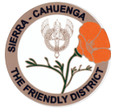
STATED MEETINGS, September thru June / 3rd Thursdays @ 10AM
WHWC President, Rachel Garcia rachelwhwc@gmail.com
Newsletter Publisher, Chris Wright Roper thekrazykatlady@gmail.com
---------------------------------------------------------------
 JANUARY MONTHLY MEETING
Thursday, January 18, 2024 @ 10AM

WOODLAND HILLS COUNTRY CLUB
21150 Dumetz Rd., Woodland Hills, CA 91364

Cost $38 - Check, Venmo, Credit Card or Cash (If paying with cash, please bring exact bills)
*******
IF YOU HAVE A “STANDING RESER”, ONLY A DECLINATION IS NECESSSARY:
RSVP your attendance (yes or no!) to:
CHRIS WRIGHT ROPER
Landline: 805/791-3915 thekrazykatlady@gmail.com
Center For Assault Treatment Services (C.A.T.S.)
Speaker: Regina (Gina) D'Aquilla, MFS, BSN, SANE-A/SANE-P
Program Manager, Dignity Health - Northridge Hospital

https://www.dignityhealth.org/socal/locations/northridgehospital/about-us/center-for-assault-treatment-services

Gina D'Aquilla is a Family Nurse Practitioner and a recognized expert in forensics covering sexual assault, strangulation, and child physical abuse. Her experience as a registered nurse began in the acute care settings of the hospital at a level two trauma center in Ventura, CA. In 2012, Ms. D'Aquilla joined Ventura County's forensic program as a sexual assault nurse examiner. Forensics quickly became a passion for her, leading her to a full-time forensic career.

In 2014, she was promoted to Forensic Examiner Program Coordinator, overseeing the medical coordination of Ventura County's two nationally accredited Child Advocacy Centers. With an understanding that evidence obtained in forensic medical examinations can be challenged in court and the importance of training and incorporating best forensic practice, she developed policies governing the examination of victims of violence, people suspected of committing sexual assault, and physician consults regarding sexual assault.

In the spring of 2019, Ms. D'Aquilla completed her graduate degree, earning a Master's in Forensic Science from National University. Her master's research investigated whether the name children were taught to identify their genitals delayed their disclosure of abuse. After graduation, she presented her findings at a national conference.

In December of 2021, she accepted the position of Program Manager at the Center for Assault Treatment Services. Gina, along with the other CATS staff, provides valuable services to thousands of victims of interpersonal violence.

MENU: DELI BOARD BUFFET with deli breads, platters of assorted deli meats & cheeses, lettuce, tomatoes, onions, pickles, condiments, crock of soup . . . AND, Chef’s-choice dessert

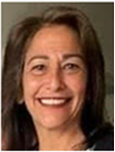 President – Rachel Garcia
Blessings for a joyous New Year!
The past year has been full of fun, fulfillment and festivities!
We celebrated our 75th Anniversary. It has been an honor to serve with Betty Paravato, our District President with over fifty years of service, and so many of the other ladies that hold this club together!
As we enter into 2024, let’s focus on service projects and helping our community even more! Seventy five years strong … with the help and love of our beautiful members (including our five new members who have joined us in December), we are looking forward to serve and grow as we welcome a new year of service!

1st VP, Dean of Chairmen – Arlene Bell
There are several awareness needs celebrated in January. Though the four that get the most attention include: National Blood Donor Month, Cervical Awareness, Mental Awareness, and Poverty Awareness. The Woodland Hills Woman’s Club participates in helping those in the community, that are food deprived, housing for men women and children, and just the basic needs to live a normal life.
In January, we will be making lunches for 100 families that are residing at the hotel that is run by HOPE THE MISSION right in Woodland Hills.
I have a sign-up sheet for those interested, but please . . . if anyone would like to sign up, please call or email me.
Arlene Cell 818/963-0062 filmboss1@aol.com

2nd VP, Membership – Stephanie Knizek

What a thrill! At the December Holiday Meeting, we welcomed 5 new members to our Club!
Read all about them in a special section at the close of this Newsletter!
Also, note a new address & landline for our 1st Vice President/Dean, Arlene:
Arlene Bell
755 Wind Willow Way
Simi Valley CA 93065-6667
Landline 805/791-3556
CELL/Text 818/963-0062
filmboss1@aol.com

3rd VP, Fundraising – Freddie Ferguson
As we begin 2024, we are looking forward to an exciting and prosperous year. We will be having our first Fundraising Committee meeting in January. More info to follow. All are welcome to join in planning. We welcome your ideas!

4th VP, Fundraising – Millicent Callahan
Our December Holiday Luncheon highlighted the beautiful sounds of EL CAMINO HIGH SCHOOL’S “CAMERATA CHOIR”. Editor’s note: I HOPE THIS TRADITION NEVER ENDS!
Thank you, too, to Vicki Harris for her holiday chocolate-cookie table favors . . . always a treat!
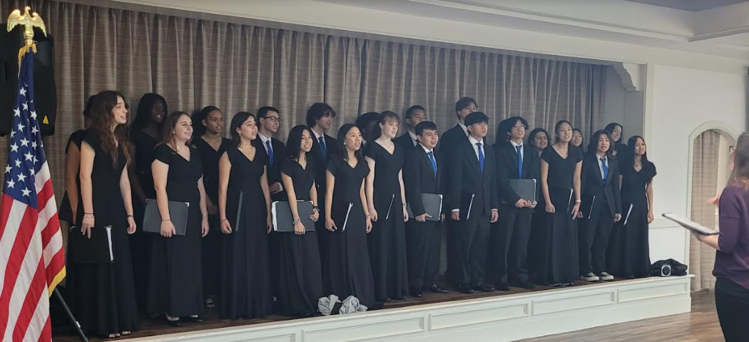

LEGISLATION/PUBLIC POLICY - Rosadel McClure, Chair
From our CFWC State Legislation Chairman, Carol Burhart
RAPE KIT BACKLOG - On November 13, the House of Representatives passed the Debbie Smith Act reauthorization bill which provides funding to law enforcement to analyze untested rape kits. DNA analysis is one of the most important methods to investigate crimes and improve the capacity of state and local prosecutors to bring these cases to court. Legislative Action Center sent action alerts in early 2023 in support of this legislation.

SIERRA-CAHUENGA DISTRICT – Betty Paravato
DISTRICT MEETING . . . happening ahead of our January Monthly meeting !!!
Please mark your calendar for the next District Meeting. It’ll be held close-by at the Canoga Park Women’s Club on Monday, January 15 (9:30AM – meeting begins at 10AM). Let’s begin the year with a grand WHWC representation! REMEMBER – our very own Betty Paravato is District’s President! Lunch $15 (Pay at the door). RSVP - ARLENE BELL: Text/Cell 818/963-0062

ARTS AND CRAFTS
Calling all crafters, artists & photographers!!
The annual District Arts and Crafts Festival will be held on March 13 and 14th at the Canoga Park Woman’s Club.
WE NEED MEMBERS TO SUBMIT items, paintings, and photographs to Yvonne Cahill (our district chairman) by
March 1. Come on ladies, I know you are all very crafty and talented, so let’s get some submissions to her by
the deadline. I have the application forms and instructions, so just give me a call (818/625-0545) or email at
bparavato@socal.rr.com and I will get them to you. It needs to be something you have made or created in 2023
(But I won’t tell if you did it before then). Did you knit something; create a trash to treasure item; paint a picture;
knitted, crocheted or quilted something, of took a beautiful picture of still life, florals, portrait, or scene that you
would like to show off; and probably anything else I did not put here. Also, we need paintings from students
grades 1-12, so do you have a contact with a school or a grandchild you find very talented? Let’s get their works
shown at this event. Any questions, please contact me.

 DISTRICT FUNDRAISER . . . Football Books
A few books that were given out at one of our meetings, did not get returned to Betty Paravato. If you have a green football book that still has the stub on the bottom, please fill it out and get it to Betty as soon as possible. If the stub & $20 are not turned in, District has NO way of identifying the holder of the book . . . if they win! If you have one of these books, please call Betty 818/625-0545 QUICKLY!

OPERATION GRATITUDE “Battalion Buddies”
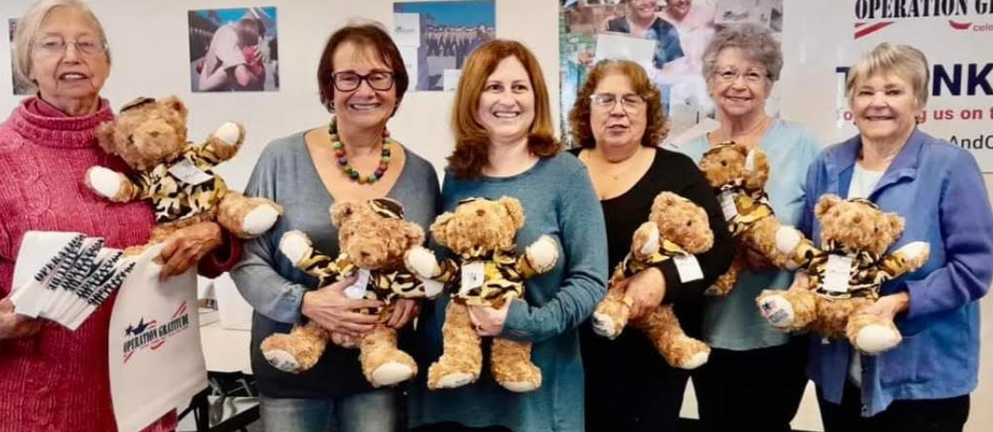
Along with other WHWC members, Cheryl Sullivan, Carol Crovisier, Bonnie Summer, MaryRose Miraglia, Ruthanne Thompson and Betty Paravato stuffed OPERATION GRATITUDE “Battalion Buddies” that will be given to the children of a deployed military and first-responders!

CALIFORNIA WILDLIFE CENTER – Glenn Ellis, Chair
. . . a wildlife hospital in Malibu WHWC has been supporting since 2003
During 2023, California Wildlife Center (CWC) received over 3,535 animals - over 170 species. Among those species are sea lions, skunks, peregrine falcons, owls, crows, hummingbirds, squirrels, opossums, bobcats, coyotes and deer.
Some of the animals are orphaned infants which just need nurturing warmth and formula so they can grow to an age where they can be released. Volunteers supply much of this care under staff supervision. One of our members, Glenn Ellis, is a satellite of CWC and cares for up to 30 infant squirrels (and infant skunks) in her home with the help of other volunteers.
But most of the animals that arrive at CWC are injured or ill and need the professional care of the wildlife veterinarian and techs who staff CWC. This is often a long-term process, which fortunately usually results in the animal healing and being returned to the wild.
Want to know more about CWC and what you should do if you find an infant or injured animal? Call the California Wildlife Center at 818/591-9453 or go to the CWC website: cawildlife.org. Or just for interesting facts, cawildlife.org/faq/. By law, caring for wildlife can only be done under a Permit from the California Department of Fish and Wildlife.

WEST VALLEY FOOD PANTRY – Nona Mason, Chair
At our October meeting, we heard from the Pantry’s Director, Debbie Decker, who shared wonderful stories of community service that the pantry offers. Volunteering at the Pantry is a great way for WHWC to help our community. One way to do this is by having a group of us go to the Pantry and help with their preparations. It would be a 2-1/2 hour shift on a weekday morning. Once we know if there is interest, we can work out the details. If you are interested in helping, contact Nona Mason – Cell/Text 818/903-5549 nrmason1@aol.com

FISHER HOUSE – MaryRose Miraglia, Chair
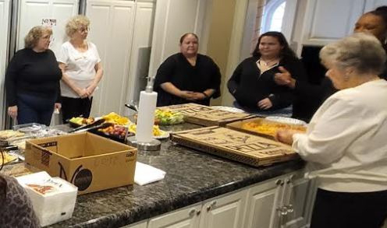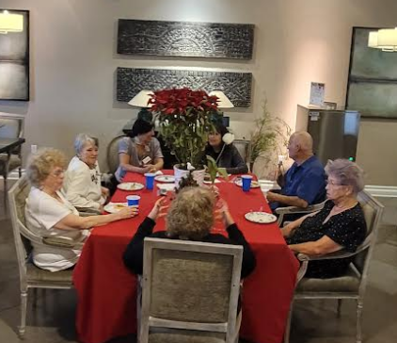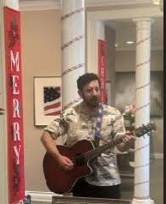
On Tuesday December 11, our club sponsored a Holiday lunch for the residents at the Greater L.A. FISHER HOUSE. The Fisher House provides similar services as the Ronald McDonald House but for Military Families. On this day, the Fisher House had 32 families staying there, with a member of their family receiving either inpatient or outpatient care.

It was a lovely lunch where we all enjoyed a pizza party in the house dining room. Five WHWC members (Betty Pavarato, Ruthanne Thompson, Roberta Marlowe, MaryRose Miraglia and Janet Morris) participated and got to partake in lunch with the residents that were in attendance. Some residents were not present due to them being in the hospital with their family members receiving care. Fortunately, when they returned to the Fisher House that evening they also enjoyed the pizza party feast for their dinner.

Thank you to our member, Janet Morris, for arranging for her son, Andy Morris, to return on December 20 and play a guitar concert for the residents. I spoke with Sandra the next day and she told me how happy Andy’s guitar concert made the residents. She also raved about how great Andy played.

We are so glad we got the opportunity to have lunch with the residents and hear from them how grateful they are to have a place like the Fisher House to stay, while their loved ones are getting care at the VA.

LUSKIN OIC “TOYS & JOYS” EVENT
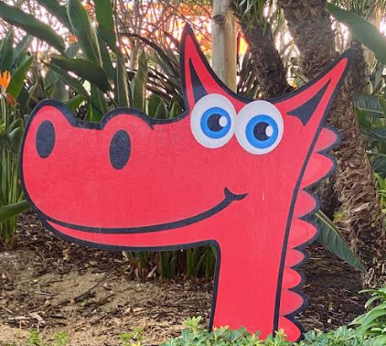

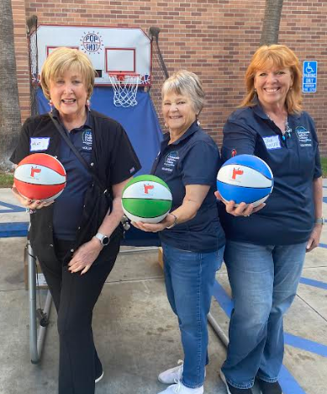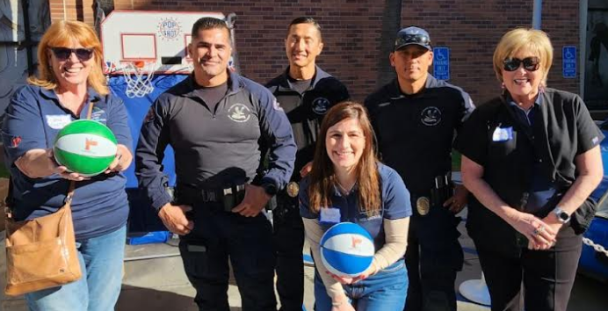
What a wonderful time Jana Huntley, Vicki Harris and Betty Paravato had at the Luskin Orthopaedic Institute for Children’s giving away of basketballs to the 1000’s (at least it felt like over a thousand) kids and their families who stood in line for hours to get all kinds of holiday goodies. They waited for Santa Claus to be delivered by helicopter who then repelled down the building to greet all those waiting so patiently for him to arrive. After that, the line started to move through the maze of giveaways for each child and family. We would look down and around the buildings hoping to see an end to the line, and after several hours we finally saw the last of them approach our booth. The kids were so excited to shoot baskets at our booth as they waited for Santa to see them. Great day, lots of holiday spirit. We hope more of you will sign up to help out next year.
CHECK IT OUT! https://www.youtube.com/watch?v=eG1r-LSgYek

GUADALUPE CENTER FOOD PANTRY – Mary Escherich
When the holidays are over, all those generous people out there who remember the hungry families during November and December, seem to forget in January that they still need food – especially things like powdered milk, peanut butter, and canned soups. We give a lot to the West Valley Food Pantry (and should continue to do so), but let’s not forget the other pantry in our area that helps out so many families who cannot get to the food pantry on Shoup and count on the Guadalupe Center to ease their hunger. If you have questions about the pantry or want to volunteer to help out, please contact Mary Escherich at 818/439-1312 or marybrooks@gmail.com. All donations greatly appreciated.

CASA PACIFIC HOME TOUR – Betty Paravato
In December eight of us toured the facilities at Casa Pacifica Centers for Children & Families. Our donor relations officer, Madeline Sattler took us all around the 24-acre facility for foster children from ages ten to eighteen. While we were not allowed inside the facilities where children might be (due to HIPPA rules), we got the low down on all that this wonderful facility is doing to help out foster children find families to live with and hopefully get adopted to. We learned they are now starting on a new use for their facilities to bring in and help out the foster children who have aged out of the system. They now house the 18 to 24 year olds – helping them go to college, get jobs, learn how to budget their finances and basically learn how to deal with life. Such wonderful goals. If anyone would like to see the place in the future, contact Betty Paravato to set up another tour – definitely worth seeing and discovering how our donations help them out.

OUR CHRISTMAS COOKIE DELIVERIES!
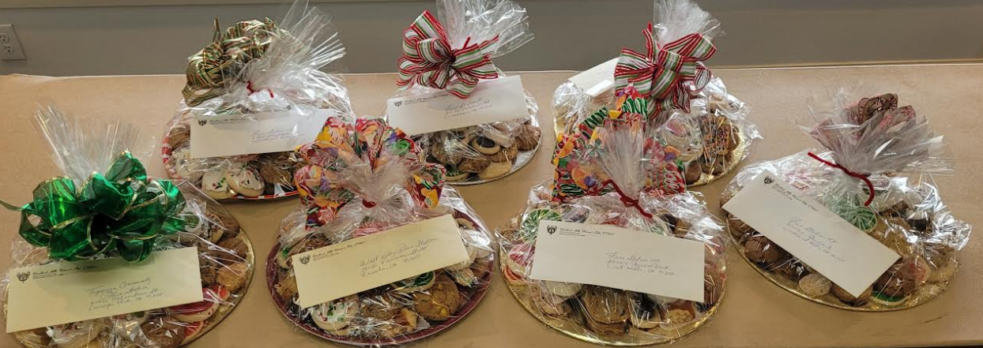
Thanks to all who donated cookies . . . plenty for the 7 beautifully assembled cookie trays for our local heroes!
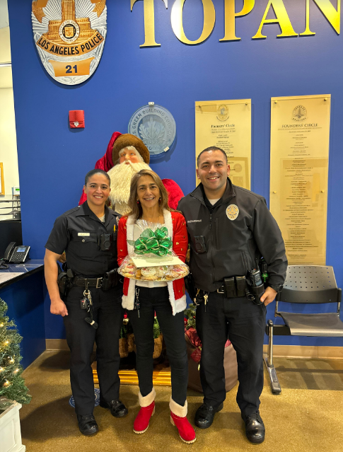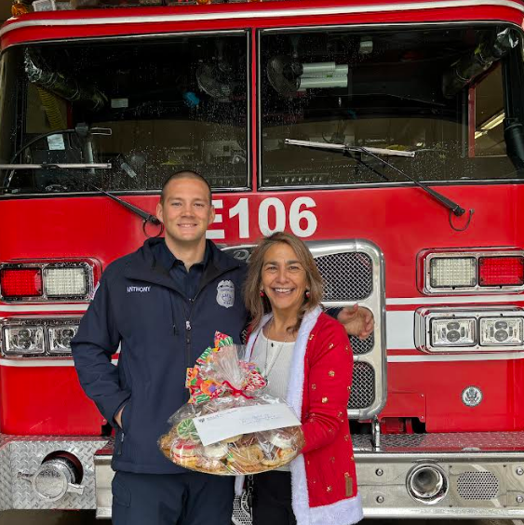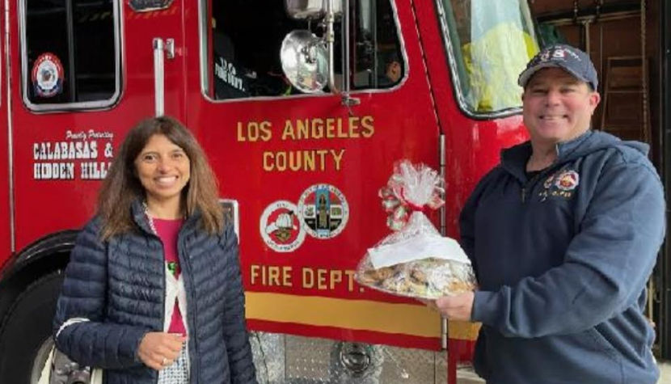

BOTTLE CAPS FOR BUDDY BENCHES - BETTY PARAVATO
Don’t forget to keep gathering those plastic water bottle caps and any other plastic caps of any size (like from orange juice bottles, mayonnaise jars, cough syrup, milk jugs – anything and any color as long as it is plastic. These caps are melted down and made into a bench to be delivered to an elementary or junior high school where the students are reminded that if they see anyone sitting on this bench, that they need a friend or just someone to talk to and make them feel wanted and liked. Helps so much with bullying and mental problems the student may be having. Simple project for everyone to be part of. Bring your collection to monthly meetings!

LUNCH BUNCH - Cheryl Ayers, Chair
Thursday, JANUARY 25 @ 11:30AM
MARMALADE CAFE
4783 Commons Way (in THE COMMONS), Calabasas
Lots of parking with easy access . . . Order off the menu - beer & wine is available.
We have a great time socializing please plan to attend.
Please RSVP if you even think you will attend so that enough
spaces for seating us together will be available.
CHERYL: Landline 818/884-9313 home Cell/Text 818/317-2685 cell and texts cheryllcornell@yahoo.com

 BOOK CLUB – Betty Paravato
Our wonderful Book Club is thriving! If you want to join contact Betty. Following is the Schedule of upcoming meetings:

January – Eileen Gouse
February – Cathy Stewart

If you are interested in holding a meeting at your home after February, please let Betty know. Your responsibility as hostess is to be the discussion leader on the book you chose and to provide refreshments. All WHWC members are welcome! Hope to see you!
BETTY Landline 818/716-6299 Cell 818/625-0545 bparavato@socal.rr.com

POSTSCRIPTS BUNCO FUNDRAISER 
Enjoy a day of BUNCO while supporting Postscript's annual fundraiser! The funds raised will be given to TARA (The Animal Rescue Alliance)

FRIDAY, January 26
9:30AM until 1:30PM
Granada Hills Woman's Clubhouse
$25 (coffee, snacks, lunch & raffle prizes included)

Tickets will NOT be sold at the door.
If you're interested in attending, Betty Paravato, Chris Roper or Kay Winnert have tickets.


Word from our Area C President, BJ Addis, “If you or your club ladies would like to contribute to help Lahaina, Maui, rebuild, information follows! Thanks very much! Mahalo nui loa!” ** BJ

CHECKS payable: Hawaii Community Foundation (Maui Strong Fund in the Memo line)
MAIL TO: HAWAII COMMUNITY FOUNDATION, 827 FORT STREET, HONOLULU, HI. 96813

 WE GOT MAIL!
Our Club received THANK-YOU acknowlegement letters for our monetary donations to the following organizations:
CITY OF HOPE in support of Breast Cancer Research
CHILDREN OF THE NIGHT
HOPE THE MISSION
ADOPT ME RESCUE
HAWAII COMMUNITY FOUNDATION ("Maui Strong Fund")
OPERATION GRATITUDE
THE PAINTED TURTLE CAMP

 HAPPY BIRTHDAY, JANUARY BABIES!
Roberta Marlowe (8) – Liz Strother (9) – Nona Mason (21) – Glenn Ellis (28)

DATES TO KEEP ON YOUR RADAR!

Thursday, January 18 – WHWC Monthly Meeting

Monday, JANUARY 15, 10AM – DISTRICT MEETING @ CPWC Clubhouse

Thursday, JANUARY 25 @ 11:30AM – LUNCH BUNCH @ Marmalade Café in The Commons

Friday, JANUARY 26 @ 9:30AM – POSTSCRIPTS BUNCO @ GHWC Clubhouse

Thursday, MARCH 14, 10AM – DISTRICT ARTS & CRAFTS FESTIVAL @ CPWC Clubhouse

Monday, MARCH 18, 10AM – DISTRICT MEETING

Friday, APRIL 12 – SIERRA-CAHUENGA DISTRICT CONVENTION @ Calabasas Country Club

Sunday, APRIL 28, 1PM until 4PM – Canoga Park Women’s Club WINE TASTING

MAY 16, 17 & 18 – GFWC CALIFORNIA STATE CONVENTION at the HOLIDAY INN, San Jose

Saturday, MAY 18 – Canoga Park Women’s Club FASHION SHOW

Monday, MAY 22 -OR- JUNE 3, 10AM – DISTRICT MEETING

CANOGA PARK WOMEN’S CLUB BINGO: Fridays, 6PM-9PM
RSVP, a must! Amy Sturgiss 818/324-4181 Amy.Sturgiss@gmail.com
Jan 19 - SLOPPY JOE BINGO
Feb 16 - BINGO BLING
Mar 15 - IRISH DINNER BINGO
April 19 - SPRING-O BINGO
June 14 - HOT POTATO BINGO

 NEW YEAR’S RESOLUTION TIME ??? PERHAPS THIS “INSPIRATION” SHARED BY BETTY PARAVATO AT DECEMBER’S HOLIDAY MEETING WILL GET US STARTED (??)

SIMPLE FORMULA FOR LIVING: Live beneath your means – Return everything you borrow – Stop blaming other people – Admit it when you make a mistake – Give clothes not worn to charity – Do something nice and try not to get caught – Listen more, talk less – Everyday take a 30 minute walk – Strive for excellence, not perfection – Be on time. Don’t make excuses – Don’t argue. Get organized – Be kind to unkind people – Let someone cut ahead of you in line – Take time to be alone – Cultivate good manners – Be humble – Realize and accept that life isn’t fair – Know when to keep your mouth shut – Go on an entire day without criticizing anyone – Learn from the past. Plan for the future – Live in the present – Don’t sweat the small stuff . . . it’s all small stuff!

WELCOME, FIVE NEW WHWC MEMBERS !!!!

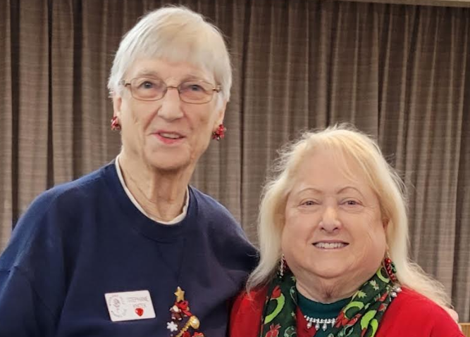
Sharon Billone
21032 Hackney St.
Canoga Park CA 91304
818/321/1808
sharonbillone@yahoo.com
DOB 9/3
I have been retired since my husband’s passing 11 years ago. I find many paths to keep me busy. I am a volunteer at the Autry Museum for the past 15 years. I also have joined the Tea Cup Divas, Black and Bling, The Ramblin Red Roses, Jonsoon Comprehensive Cancer Foundation and Brandeis. I have many places to go if I want to stay busy. I have a beautiful close-knit group of girlfriends and a daughter that I adore. I feel the Woodland Hills Women's Club completes my circle of activities. Every woman that I have talked with was so wonderfully warm and caring

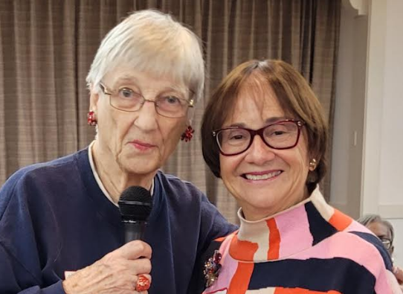
Carol Crovisier
18150 Oxnard St., #90
Tarzana CA 91356
818/398-1877
carolcrovisier@gmail.com
DOB 4/22
My name is Carol Rothberg Crovisier. I am retired and a widow. I had a second career for 20 years as a Senior Paralegal who wrote clinical study agreements between pharmaceutical companies and learning institutions and hospitals. I love to read, hike and shop.

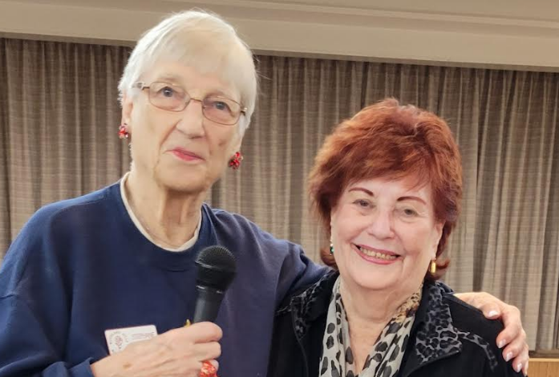
Ilene Greenspan
6750 Whitsett Ave., #266
Valley Glen CA 91606
818/472-1216
Tellady2@hotmail.com
DOB 7/18
My husband passed away in 1973 leaving me with 2 children: 14 month-old son and almost 6 year-old daughter.
Sometime later I became a reading specialist for the New York City school system.
I was also a travel agent for a short time, and sold telephone systems after the AT&T breakup.
I moved with my children from NY to Woodland Hills in 1982 since my brother and mother also lived here
Ultimately, I opened my own Telecommunications consulting company which ran for about 25 years.
In 2002, I received an offer from CSUN to become an Admissions Evaluator. I loved helping incoming young people navigate the process. I retired from CSUN 2016. My department gave me a wonderful retirement party, over 100 people from various depts. Plus some of the students that I helped. I still keep in touch with some of them.
My passions? I raised my children, saw that they were educated and become good humans. They are now raising their own awesome kids. I am passionate about helping young people navigate society. Especially if they have been abused. Adults as well. I am also passionate about feeding the hungry. No one in this country should go hungry, especially children.
I am also a red hatter!!! I live in a retirement community where I'm always helping people who need help

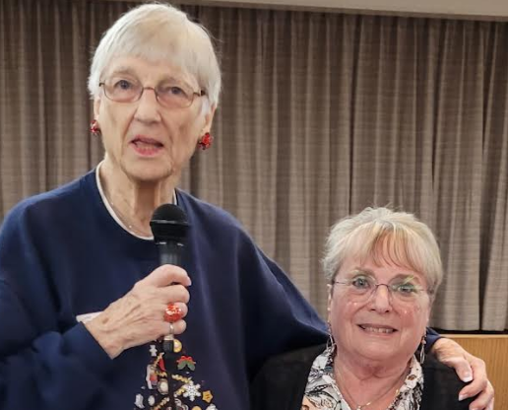
Linda Ross
6738-5 Encino Ave
Lake Balboa CA 91406
Landline 818/343-2053 CELL 818/207-9674
Lindar617@Att.net
DOB 6/17
I’m a retired business manager. I’ve been completely retired for about 6 years. I originally retired in 2012 but two of my clients requested I continue doing their books, so I did. When my boss decided to merge with another firm, I decided I would leave when he moved. I am an active member of the Red Hat society and am also a member of the Johnson Cancer Center Foundation and Brandeis University study groups. My main charities are children’s health and military related. I’m very excited to be a new member of WHWC.

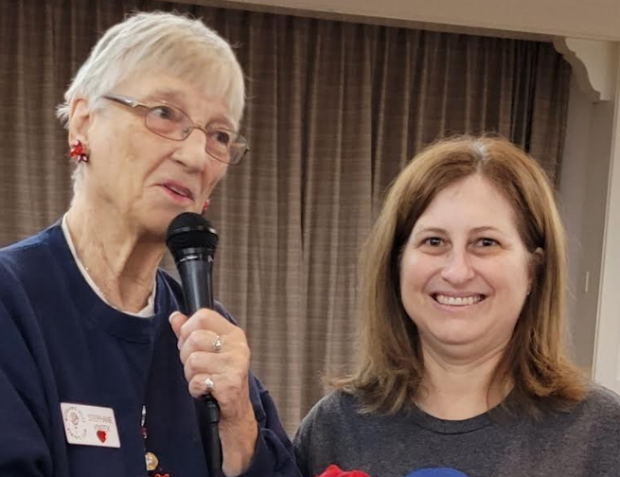
Bonnie Summer
4236 Kingfisher Rd
Calabasas CA 91302
818/808-9301
bonniesummergerontology@gmail.com
DOB 8/18
As a placement and referral specialist, I assist families in finding senior living facilities that meet their loved ones' needs. I hold a master's degree in gerontology and am a married mother of two daughters, aged 13 and 16.

