APRIL 2023 NEWSLETTER
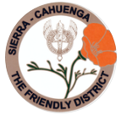
STATED MEETINGS, September thru June / 3rd Thursdays @ 10AM
WHWC President, Rachel Garcia rachelwhwc@gmail.com
Newsletter Publisher, Chris Wright Roper thekrazykatlady@gmail.com
---------------------------------------------------------------
APRIL MONTHLY MEETING
Thursday, April 20, 2023 @ 10AM
WOODLAND HILLS COUNTRY CLUB
21150 Dumetz Rd., Woodland Hills, CA 91364
Cost $36 - Check, Venmo, Credit Card or Cash (If paying with cash, please bring exact bills)
IF YOU HAVE A “STANDING RESERVATION”, ONLY A DECLINATION IS NECESSSARY:
RSVP your attendance (yes or no!) to: CHRIS WRIGHT ROPER
Landline: 805/791-3915 thekrazykatlady@gmail.com

PACIFIC LODGE YOUTH SERVICES
Speaker, Jodi Reneaud
Community Engagement and Volunteer Manager and is responsible for recruiting, training and placing Volunteers and Mentors in all program areas including our Temporary Shelter, Short-Term Residential programs, our Foster Family Agency and our Transition Living programs.
During the past few years, a lot of changes have taken place at Pacific Lodge . . . come & hear all about them & learn what’s going on!

LUNCHEON MENU - FULL SALAD BAR WITH CHICKEN & TUNA SALAD, ASSORTED DRESSINGS, WARM ROLLS & BUTTER, CROCK OF SOUP, CHEF’S CHOICE OF DESSERT
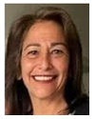
President’s Message – Rachel Garcia
Spring Showers bring May flowers! We have had an eventful month. A group of ladies took a tour of OPERATION GRATITUDE’s facility -- stuffing “Battalion Buddy” bears for the soldiers’ children! We visited HAVEN HILLS who support domestic violence and their families. We donated clothing and made a monetary donation. Ruthanne Thompson has taken on our PAINTED TURTLE CAMP project, and her committee met on March 29. We also supported our local firefighters by hosting a St. Patrick’s lunch for Company B lunch at FIRESTATION 105. We have formed a Vetting Committee to go through and edify our current charities. Some charities have made changes because of Covid. We will be collaborating with the members to have an organized list to donate to, including those who introduced each charity for recognition of work done throughout the years. We have started a fun and successful time after the adjournment of our General Meetings with 30-minute committee meetings. It has served to help with communication with members. Coming up in May, we will hold a Bunco fundraiser! The WOMEN’S WARRIORS are in need of baby items. We are volunteering in May to help with their “Baby Shower”. For our May General Meeting, we are excited to have a speaker from FISHER HOUSE. We will be honoring our Veterans! We are asking you to invite your loved ones who have served as well as providing pictures of your heroes for our slide show presentation. Those pictured do not need to be in uniform. If you loved them and they served . . . and you want to honor them, send pictures to Millicent at programdirector.whwc@gmail.com
Save the August 5 date for our Annual Summertime Tea! We’ll also be celebrating our Club’s 75th Anniversary!

1st VP, Dean of Chairmen – Arlene Bell
APRIL SHOWERS
Spring is in the air, along with wonderful rain. Who would have thought that we would be blessed with this fantastic weather? There is a plethora of holidays in April. Wear blue to support Autism awareness! National Garden month . . . Volunteer, for a good cause week . . . Plant a tree for Arbor Day -- all in the month of April!
How exciting to see our club with New Chairs and Committee members. The club will only grow with the energy and ideas that are developing. Thanks to all of you who are making it happen.
DISTRICT CONVENTION – Friday, APRIL 14
The Sierra-Cahuenga District convention is coming up on Friday, April 14, from 9AM to 4:30PM at the Air-Tel Hotel in Van Nuys (newly remodeled and completely fixed up). The cost is $70 which includes your buffet chef salad with lots of good choices to add to your plate. We will have vendors with great things to buy, a display of the winning items from the Arts and Crafts Festival, fabulous door prizes, and a way to just have time to be together. I hope I can count on a lot of you to attend with me – YES? Carpooling will be arranged, if needed. Arlene Bell: CELL/Text 818/963-0062 filmboss1@aol.com
District President, our Betty Paravato, adds: “I like what the state yearbook says about convention – Why do we go to Convention? We go to be educated, re-energized, and applauded, to renew friendships, and to make new friends all in a short period of time. We go to boast of our accomplishments, to praise others for their accomplishments and finally we go to convention to work on ways to strengthen our organization.”
APRIL IS NATIONAL CHILD ABUSE MONTH
NATIONAL CHILD ABUSE MONTH recommends the importance of families working together to
prevent Child Abuse and Neglect. Prevention services and supports developed by this
collaboration can help to protect our children and families.
THIRTY-MINUTE MEETINGS
After our General Meetings, we will hold 30-minute meetings of all chairs, committee members, and, of course, any interested members. We will provide a description of the chair’s duties and committee members’ duties. Please bring with you any new projects that you are interested in. TOGETHER WE CAN MAKE IT HAPPEN.
VICTORY FOR VICTIMS
C.A.T.S. is having their 21st Annual Walk/Run, April 15 at Hansen Dam, starting at 8:00AM.
WINE PULL
Read all about our TEA’s “Wine Pull” event under Freddie’s reporting! We need everyone’s help!

2nd VP, Membership – Stephanie Knizek
A big thank you to all of you who have turned in their medical forms. I have almost all of them! You all have been good about giving me names of potential new members. I am following up on all of them and will be bringing new members in soon.

3rd VP, Fundraising – Freddie Ferguson
Our year is marching along planning our big event the Summer Tea. We still need 8 table decorators (teams are welcome). Also, we need member-hostesses to hostess a table for some of the table decorators who have committed to decorating more than one table.
Please remember to support our TEA’s “WINE PULL” event! We will need 60 bottles of wine with a retail value of $25+ each. If you’d rather contribute monetarily, the suggested donation is $15 for each bottle of wine you would like to donate. Irene Deak has graciously volunteered to do the purchasing of wine. This is an easy way for our club to fundraise without a lot of work. Please be generous. Deliver your bottles of wine to Arlene Bell or bring them to our monthly meetings.

Silent Auction basket making will take place in late July at Saint Bernardine's Church’s Parish Hall. All hands on deck, PLEASE!

Solicitations for our BAKE-LESS BAKE SALE will appear in your mailbox soon! No baking! No shopping! Nothing to do but drop a check into the mail for the amount you might spend on a cake or a batch of cookies!

Lastly, we will have a possible Bunco in May at Saint Bernadine's Church. ALL ATTEND, PLEASE – AND, invite your friends!

Treasurer – Glenn Ellis
MEMBERSHIP DUES ARE PAST-DUE AFTER MARCH 31.
If you’re tardy paying your dues, please include the “late fee” of $10. Send off your $70 check to our Glenn Ellis, 5526 Mason St., Woodland Hills CA 91367 (or, you can Venmo your payment).

VETERANS AFFAIRS - Rosadel McClure, Veterans Chair 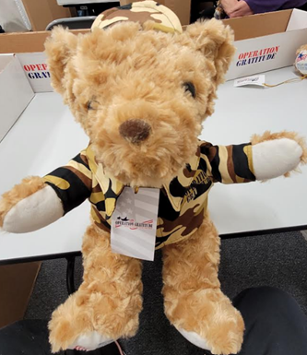
On Thursday, April 27, from 9:00AM until 11:30AM, we will again stuff “Battalion Buddies” (Teddy Bears) at OPERATION GRATITUDE in Chatsworth.
When they leave, deployed troops give these bears to their children to remember them. The need is great! OPERATION GRATITUDE receives requests for hundreds of bears every month.
We had so much fun last time we decided to make it a regular event, followed by lunch. If you missed last time, please consider joining us on the 27th.
There will be a sign-up sheet and a link to make your reservation at the April meeting.
LUNCH BUNCH (after Operation Gratitude)
Thursday, April 27 at 11:30AM
21743 DEVONSHIRE ST., CHATSWORTH
EAST OF TOPANGA CANYON BLVD / WEST OF OWENSMOUTH
Free parking in their lot
LUNCH SPECIAL $18 - INCLUDES TAX & TIP
CASH OR CHECK ONLY PAYABLE TO CHERYL AYERS
RSVP to Cheryl at CELL/Text: 818/317-2685 cheryllcornell@yahoo.com

Ruthanne Thompson, Chair
GIRLS LOVE MAIL will be revitalized at our April meeting. This is an organization that collects handwritten letters of encouragement for women who are newly diagnosed with breast cancer. This is more than a handwritten letter. You would be sending a handmade gift. This is an endeavor that costs no money but will give emotional support. Every other month, we’ll join as a group to write a few words of encouragement to an unknown person who will benefit from our act of kindness.

Sample letters will be provided as well as blank cards/stationery and pens. Your completed letters will be collected by Ruthanne who will see that they are delivered to GIRLS LOVE MAIL!

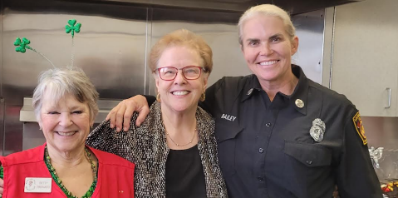
Here's a picture of their LADY Chief . . . Jen Bailey!
HOORAY FOR THE WOMEN of THE LAFD!
Much THANKS to all members (Ruthanne, Roberta, Betty, Freddie, MaryRose, Irene, Jeanne, Cheryl A., Arlene, Vicki, Aimee, Cary, Vera, Kay & me) who participated in the March 9 FIREMEN'S LUNCHEON for ‘Company B’ at Station 105. They love it when we come . . . and it was another resounding success! Their Captain ‘specially requested a Corned Beef lunch – and our members more than filled the bill!

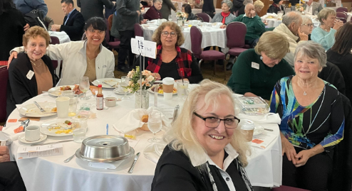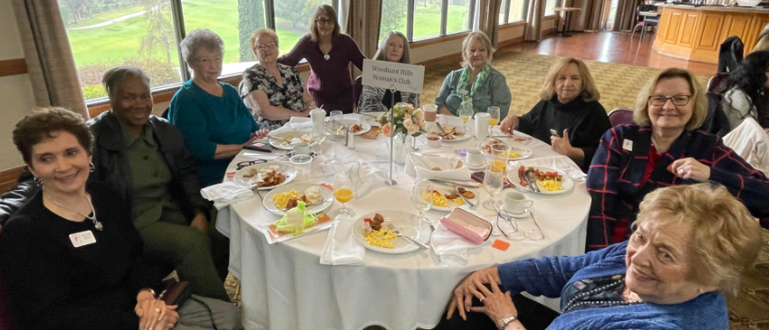
Our Club was glad to sponsor a table at ANGELS WAY’s 5th Annual Breakfast Gala that was held at the Woodland Hills Country Club on March 15. BRIGHT & EARLY . . . we gathered to hear the heart-felt stories about the wonderful work Angels Way does! No wonder this is one of our Club’s cherished philanthropic endeavors!

I’M SURE WE ALL AGREE WITH MYRA who shared, “I’d like to add a shoutout to thank (our Club’s chocolatier) Vicki for those deliciously sinful treats she made for us. I lost all willpower and ate the mouth-watering cookie yesterday and celebrated St. Patrick’s Day with the shamrock treat today”.

HOPE THE MISSION
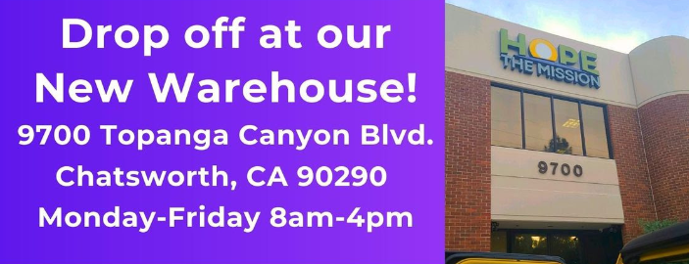

TIME TO SOCIALIZE ? from Betty Paravato
A few of us WHWC members were together the other day and thought it would be nice to do a social event in early June . . . just to be together and have fun – not to raise any money. We had gone to a charity event where they did a “paint night”, and we all had a riot watching each do our paintings. There were definitely no artists among us, but so much fun to do together! Some of us are going to hang our paintings in the garage, they were that good, HA! HA! Anyway, we want to bring it up at our April meeting and see how you all feel about doing something like this . . . so please plan on attending and letting us know what you think. There would be just the cost of what the teacher brings (Not much . . . the canvas & the paints). If we do this, would you prefer a Saturday evening or would you prefer a mid-week evening or afternoon? I hope to hear from everyone then. Betty: Cell 818/625-0545 bparavato@socal.rr.com

BOOK CLUB, ANYONE?
A few of us were talking about starting up our WHWC Book Club again! We’re wondering who else might be interested. What we are proposing is anyone interested, let Betty Paravato know. Then, we would all get together, choose a time and place to hold our in-person gatherings each month, and discuss how we were going to run it. So, we will start there and see what happens. Right now, there are three members interested in starting it up again!

FISHER HOUSE TOUR, MaryRose Miraglia, Chair
WHWC will be taking touring the FISHER HOUSE on Wednesday, April 5 at 11:30AM. Address: 11301 Wilshire Blvd, BLDG 523, Los Angeles 90073.
We are carpooling. If you would like to join the carpool, contact: Arlene Bell 818/963-0062.

FISHER HOUSE FOUNDATION is best known for the network of comfort homes built on the grounds of major military and VA medical centers.
Click the link to read about the Fisher House https://www.greaterlafisherhouse.org/about
(The Organization has an extensive “wish list” for those wishing to donate needed items. You can contact MaryRose for a copy! Cell/Text 818/577-3344 mrmiraglia56@gmail.com

WE GOT MAIL!
SEPULVEDA VA MEDICAL CENTER thanking us for our donation of 50 Valentine cards for their Vets
CHILD DEVELOPMENT INSTITUTE thanking us for the opportunity to speak at our March Meeting and for our monetary donation.

DATES TO KEEP ON YOUR RADAR!

Wednesday, APRIL 5 @ 11:30AM – tour of FISHER HOUSE, Downtown LA (Contact MaryRose Miraglia Cell/Text 818/577-3344 mrmiraglia56@gmail.com

Thursday, APRIL 20 @ 10AM – WHWC MONTHLY MEETING @ Woodland Hills Country Club

Friday, APRIL 14 – SIERRA CAHUENGA DISTRICT CONVENTION @ AirTel Hotel, Van Nuys

Thursday, APRIL 27 from 9:00AM until 11:30AM - OPERATION GRATITUDE . . . stuffing “Battalion Buddies” (Teddy Bears) at their Chatsworth facility.
LUNCH BUNCH to follow at LOS TOROS (Devonshire, east of Topanga Canyon).

Friday, APRIL 28 – WESTLAKE WOMEN’S CLUB Fashion Show Luncheon @ Hyatt Regency, Westlake

APRIL MAILING - Expect to receive the WORK-LESS, "BAKE-LESS BAKE SALE" -- WATCH YOUR MAILBOX !!!

OUR “SUMMERTIME TEA” WILL BE HELD SAT., AUGUST 5 !!!
Ask your friends & relatives to SAVE THE DATE !!

