

JANUARY 2023 NEWSLETTER

STATED MEETINGS, September thru June / 3rd Thursdays @ 10AM
WHWC President, Rachel Garcia rachelwhwc@gmail.com
Newsletter Publisher, Chris Wright Roper thekrazykatlady@gmail.com
---------------------------------------------------------------
JANUARY MONTHLY MEETING
Thursday, January 19, 2023 @ 10AM
WOODLAND HILLS COUNTRY CLUB
21150 Dumetz Rd., Woodland Hills, CA 91364
Cost $36 - Check, Venmo, Credit Card or Cash (If paying with cash, please bring exact bills)
*******
IF YOU HAVE A “STANDING RESER”, ONLY A DECLINATION IS NECESSSARY:
RSVP your attendance (yes or no!) to: CHRIS WRIGHT ROPER
Landline: 805/791-3915 thekrazykatlady@gmail.com
RESERVATION DEADLINE: Noon, January 13
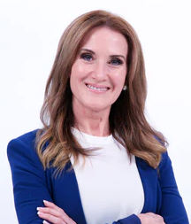
mental preservation & prevention – brain research
Rather than an in-person speaker, one of DR. CAROLYN LEAF’s very informative videos will be shared
Dr. Caroline Leaf is a communication pathologist and cognitive neuroscientist with a Masters and PhD in Communication Pathology and a BSc Logopaedics, specializing in cognitive and metacognitive neuropsychology. Since the early 1980s she has researched the mind-brain connection, the nature of mental health, and the formation of memory. She was one of the first in her field to study how the brain can change (neuroplasticity) with directed mind input.
To learn more about Dr. Leaf, click on: https://drleaf.com/pages/about-dr-leaf

MENU: PASTA BUFFET- GARDEN SALAD, CHICKEN MARSALA, PASTA WITH MARINARA OR ALFREDO ON THE SIDE, GARLIC BREAD, CHEF’S CHOICE OF DESSERT

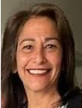
President’s Message – Rachel Garcia

Happy New Year! Can you believe, it's 2023?
We are looking forward to the coming year with openness and delight.

A greeting sent for your new year
With wishes for you, my dear:

May you have kindness shown to you.
May you have compassion for others, no matter who.
May you always lend a helping hand.
May you live your beliefs and take a stand.
May you find blessings in simple things.
May you be thankful for each day it brings.
May you overcome challenges that appear.
May you not give in to fear.
May you be happy each day.
May life be good to you in every way.

Don't focus on the challenges, look for the good in each and every day. And with this new year approaching, have an attitude of gratitude and your year will be filled with happiness.
Quotes Anonymous.

Be Blessed, Rachel Garcia

1st VP, Dean of Chairmen – Arlene Bell
The New Year stands before us like a chapter in a book waiting to be read. Are we prepared, we ask ourselves, for making this the best year ever? Some of us make New Year’s resolutions . . . I gave that up a long time ago.
I believe this says it all: The Word of the year is WOMAN, by Dictionary.com.

The Woodland Hills Woman’s Club is prepared to make a difference.
We will be taking a tour of the C.A.T.S facility on Monday, January 12.

Monday, January 16, DISTRICT’s BOARD MEETING at Canoga Park Women’s Club.

HOPE of the VALLEY, has sponsorship opportunities, such as “Bed-in-a-Bag” (two sets of sheets, blankets, and pillows) . . . much needed as each bed needs two sets of bedding. The donation is $50. A “Welcome Home Kit” is a $25 sponsorship. The people coming to live in these facilities have nothing. Our sponsorship will make a difference.

Dean’s Reminder -- HOURS, HOURS!

A timely reminder! Our Club’s blank HOURS SHEET is attached! Please catch-up reporting your volunteer HOURS and donation DOLLARS for the year. Email or snail-mail yours to Marsha LaRusso, 4 Plymouth Court, Laguna Niguel CA 92677 rmlarusso@msn.com

3rd VP, Fundraising – Freddie Ferguson

Holiday greetings and best wishes to you in the New Year.
Our January Bingo and February Valentine's Spaghetti Dinner have been canceled because of lack of interest by our members. If any of you have a suggestion on what you would be interested in participating in, please let me know. Fundraising is an important part of our club and is needed to fund all of the charities we support. Let's plan on making a successful year.
Our next Fundraising Committee meeting will be held on January 10 at 9:30AM via Z00M.

COME BE PART OF THE DISTRICT ARTS & CRAFTS FESTIVAL! – Betty Paravato

It’s time to gather your crafts and fine arts together and think about what you want to enter into DISTRICT’S “ARTS & CRAFTS FESTIVAL”. You may enter anything made by you in 2022. Categories are: Fine Art, Photography, holiday decorations, painting, knitting, crocheting, and much more!! Each entry has a fee of $3, if entered by March 1 -- $5, if dropped off at the door. You must drop off your pre-registered entries on Wednesday, March 22 between 9AM and Noon. Judges will come in and look at all of the entries and make their decisions. Then, on Thursday, March 23, at 10AM, the Festival will open so that you can see all the entries, and which pieces won ribbons. Lunch and entertainment included in the entrance fee of $12. Our Club is in charge of preparing lunch! If you can help on either day (or, both days), contact Betty Paravato CELL/TEXT 818/625-0545 bparavato@socal.rr.com

Do you know of a K-12 grade student who would like to enter their artwork? See the instructions for students too! If you have a child in K-12 or grandchild, please consider encouraging them to enter their artwork – no fee for students, and we would love photography from high school students too.

We all take photographs using our phone these days. Do you know how easy it is to go to Office Depot and have that special photo printed and mounted on foam board? Photographs must be 8”X10” and mounted. Look through your photos and see if there is one you would like to enter! All kinds of photos are wanted – people, sites, landscaping or just about anything you want to enter.

Contact our Club President, Rachel, for a packet of instructions. See how easy it is to enter!
Or contact District’s Chair, Yvonne Cahill yvonnepre@hotmail.com 661-948-5102

LEGISLATION – Rosadel McClure, Legislation Chair

HAPPY NEW YEAR! More women were elected governors for 2023 than ever before!
Your legislators do listen to the united voices of GFWC’s caring and concerned women. Together through GFWC we influence what’s included in and the outcome of legislation. Numbers matter!
THE GFWC LEGISLATION ACTION CENTER provides members with links to their legislators letting members know who to contact and where there is legislation supported by GFWC. My suggestion is to register for the LAC through the GFWC website.
At least one congressional committee meeting has been postponed until the senate leader received a report from GFWC. We are the voice for change through legislation.

VETERANS AFFAIRS - Rosadel McClure, Veterans Chair

The OPERATION GRATITUDE CEO and many of the most-dedicated volunteers are retired military. They are well aware of the wants and needs of deployed troops.

Every square inch of the Care packages is regularly evaluated to include only the most valued items, e.g., the strict restrictions on the size of the handmade scarves.

The need of socks is in addition to those which are part of the uniform allowance. Socks are one of the most requested and appreciated items in the Care package. We do not and have never sent underwear to the military.

Every Care package cost $17 to ship. The $17 for each Care package is paid directly to USPS. The Care Packages are sent to the proper stateside military base for delivery. Thousands of Care packages are sent to deployed military every month. The military assumes the cost of flying Care packages overseas to the proper military bases.

WHWC members donate items on the Veterans Wish List in our WHWC Yearbook every month. Our recent donation of $750 covers only a small percentage of the cost of shipment.

Operation Gratitude.com Is available to answer other questions you may have. And, to get a better understanding of Operation Gratitude, please sign up for the upcoming WHWC tour of Operation Gratitude facilities in Chatsworth.

During Covid the VA hospital would not accept any physical donations. As Veterans Chairman I intend to again solicit recommended articles needed by the VA.

COOKIE PLATTERS for LAPD & LAFD

As is our custom, COOKIE PLATTERS were assembled at our December meeting.
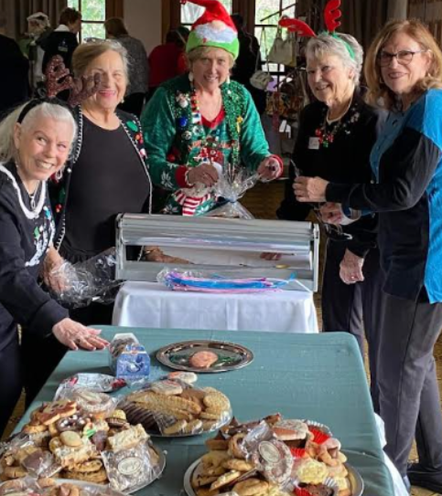
These yummy & beautiful cookie platters were delivered to our local Police & Fire Stations !!!

Special thanks to all members who brought cookies to the meeting . . . to the "assembly line" . . . to the members who made the deliveries . . . and to Betty for spearheading this annual labor of love!

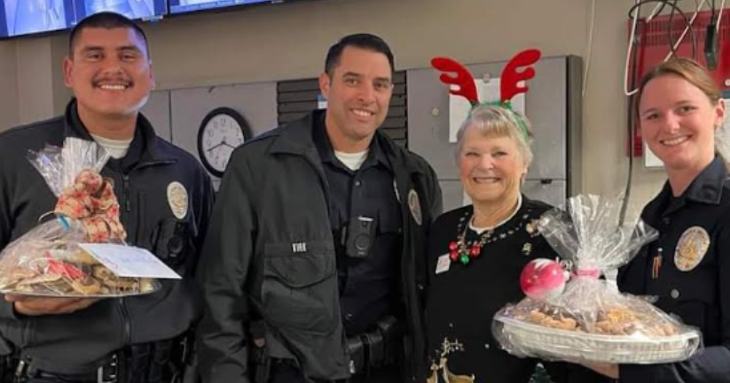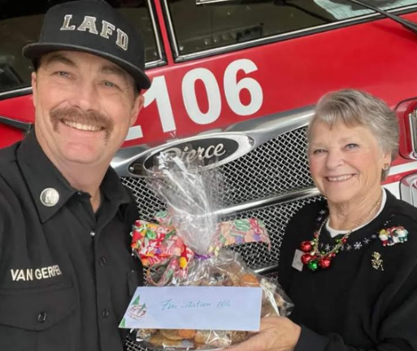

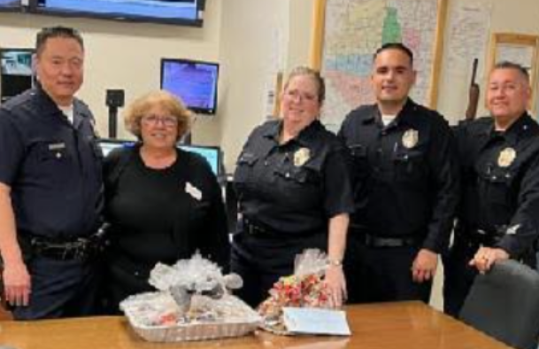

GAME TIME

GAME TIME is January 3 @ 2:00 PM at Rosadel McClure's home. All members are invited to attend. Contact Rosadel in advance so she can reserve a place for you.
Rosadel McClure, 23240 Gonzales Drive, Woodland Hills
(818) 307-8022 rosadel@aol.com

Lunch Bunch – Cheryl Ayers, Chair

Now that the holidays are behind us, Lunch Bunch is starting up again! Every 4th Thursday, we gather at 11:30AM. Our first gathering in 2023 will be on Thursday, January 26.
Restaurant to be announced.
This is a wonderful time to really get to know members of our club in a purely social setting!
So that group-seating can be arranged, RSVP your attendance:
CELL/TEXT 818/317-2685 cheryllcornell@yahoo.com

RECYCLE . . . RECYCLE . . . RECYCLE!

Reference, Page 16 of your Club Yearbook!
Bring your many “throw-away” items to our monthly meetings! They will be recycled (Most are donated to charitable organizations.)
ALSO . . . REMEMBER THE “HEIFER” & “PENNY PINES” cans that await your ‘coin’ and ‘currency’ donations at each meeting. They’re handy – on your luncheon table!

 WE GOT MAIL!

A letter from UNITED NATIONS FOUNDATION thanking us for our donation to “Shot at Life”.
A letter from HOPE of the VALLEY thanking us for our generous Thanksgiving Meals donation.
A letter from FOR THE TROOPS thanking us for a variety of playing cards, shoe insoles, 2023 calendars & many other personal items.
An email from SAVING INNOCENSE thanking us for the gift card donations/

 HAPPY BIRTHDAY, JANUARY BABIES!

Sue Michiels (2), Aimee Cornwell (8), Roberta Marlowe (8), Liz Strother (9),
Elizabeth Carlisle (18), Nona Mason (21), Glenn Ellis (28)

SHARED BY RACHEL GARCIA -- Respect, spreading kindness . . .
(Authored by Sandy Gallagher, an esteemed attorney with a successful career in banking law. Sandy regularly handled billions of dollars in mergers and acquisitions, IPOs, and other big-ticket transactions, and was an advisor to boards and top executives of Fortune 500 firms. She epitomized success in the classic corporate mold.)
There are people who say this is a hard, tough world. And that kindness has no place in business. If you want to get anywhere they claim you have to be hard boiled, you know, really tough. Well, I strongly disagree and I’ve been in the business world a long, long time. I’ll tell you what kindness works everywhere.
Years ago in Philadelphia (I love this story) a couple walked into a hotel and there was a big convention in the city and there were no vacant rooms in the hotel and they asked the clerk for a room and the clerk told them, “I’m sorry we’re all booked.” But the clerk looked at him and he believed in kindness and he saw how tired the couple was and he said, “You can have my room.” And he would sleep in the lobby and that’s what happened.
And the next morning the man sought out the young clerk and he told him how much appreciated his spirit and that he had what it took to go far, and he said, “If you will allow me, I want to build for you the greatest hotel ever erected in America.” The man was Mr. Astor. And he built the old Waldorf Astoria Hotel, and the clerk was George Bolt, who managed the Waldorf Astoria, and he became one of the greatest hotel men in America.
Kindness is something we must think about and cultivate. All too often we forget the things we should remember. We don’t weigh our words before we speak; we allow our moods to control our actions. You know, I know of nothing, which opens the door to opportunity and wins friends as quickly and as effectively as kindness. So for today I’d like you to do something that’s sure to warm your heart. As you go through your day see how many times you can perform some act of simple kindness. Doesn’t have to be a big, huge thing.
No grand gestures, just small things like holding a door open for someone... you know letting someone cut in line in front of you; maybe helping an elderly person across the street; giving a dollar or two to someone in need; even making a fresh pot of coffee for your staff. Whatever it is, just do an act of kindness; you never know when you’re being kind to another Mr. Astor.
DATES TO KEEP ON YOUR RADAR!

EVERY Tuesday @ 10AM til 11AM - READING CLUB (Via Z00M)
EVERY Tuesday @ 11AM til 11:30AM - WRITING GROUP -Topic: Journaling (Via Z00M)
EVERY Wednesday @ 8AM-9AM (except the 1st Wednesday = WHWC Board Meeting)
8AM til 9AM - WALKING WOMEN WEDNESDAYS at Orcutt Ranch - 23600 Roscoe Blvd., West hills

Tuesday, January 3 @ 2:00 PM - GAME TIME at Rosadel McClure’s home

Thursday, January 12 @ 10AM – Tour of C.A.T.S. (Center for Assault Treatment Services).
SIGN-UP: ARLENE BELL CELL/TEXT 818/963-0062 filmboss1@aol.com

Friday, JANUARY 13 @ 6:30PM - "LUCKY THE THIRTEENTH" BINGO Night – CANCELLED

Monday, JANUARY 16 - DISTRICT’s BOARD MEETING at Canoga Park Women’s Club.

Thursday, JANUARY 19 @ 10AM – WHWC MONTHLY MEETING @ Woodland Hills Country Club

Thursday, JANUARY 26 @ 11:30AM – LUNCH BUNCH (Restaurant to be Announced)

Saturday, FEBRUARY 4 @ 6PM – Canoga Park Women’s Club CASINO NIGHT

Friday, FEBRUARY 10 @ 6:30PM - "VALENTINE'S IN VENICE" Spaghetti Dinner – CANCELLED

MARCH - Expect to receive the WORK-LESS, "BAKE-LESS BAKE SALE" flyer in your mailbox!!!

Wednesday & Thursday, MARCH 22 & 23 – District’s “ARTS & CRAFT FESTIVAL” @ CPWC Clubhouse

MAY (Date, TBA) / RUN WALK VIRTUAL MARATHON



