

 SEPTEMER 2023 NEWSLETTER
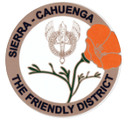
STATED MEETINGS, September thru June / 3rd Thursdays @ 10AM
WHWC President, Rachel Garcia rachelwhwc@gmail.com
Newsletter Publisher, Chris Wright Roper thekrazykatlady@gmail.com
---------------------------------------------------------------
SEPTEMBER MONTHLY MEETING
Thursday, September 21, 2023 @ 10AM
WOODLAND HILLS COUNTRY CLUB
21150 Dumetz Rd., Woodland Hills, CA 91364
NEW COST $38 - Check, Venmo, Credit Card or Cash (If paying with cash, please bring exact bills)

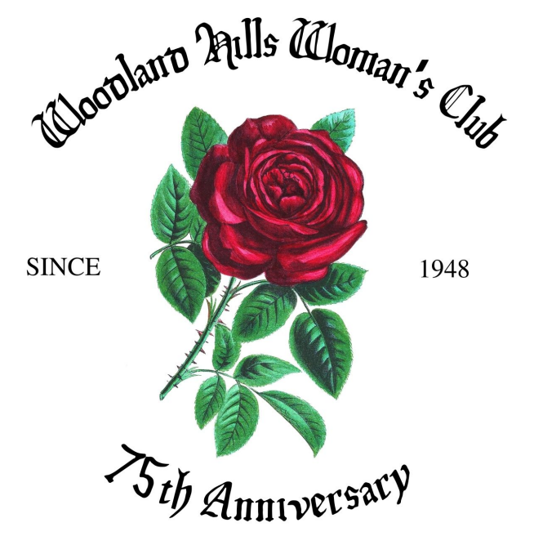

IF YOU HAVE A “STANDING RESER”, ONLY A DECLINATION IS NECESSSARY:
RSVP your attendance (yes or no!) to: CHRIS WRIGHT ROPER - Landline: 805/791-3915 thekrazykatlady@gmail.com

Luncheon Menu: Chicken Piccata, Pasta, Garden Salad & Chef’s Choice Dessert

President’s Message – Rachel Garcia
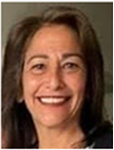
Welcome Back! We had our 9th Annual Summertime Tea to end our hiatus.
Thank you to all the Ladies who decorated tables . . . they get better every year!!!
We raised quite a bit more than last year! It was fabulous to see that we raised a tiny sum for “our” Fire Station 105. Many thanks to our vendors & every member who made a contribution to this special day!! We were honored to have Barbara Briley Beard, President of CFWC, and many of our District and sister CFWC local Clubs in attendance.
I want to thank Freddie Ferguson & Arlene Bell for “The Wine Pull” a fabulous addition that brought in extra revenue for the community charities we support!
We are looking forward to the upcoming Chairman Luncheon, discussing events to help our community.
Our September General Meeting will be honoring & congratulating our 75th Birthday as the Woodland Hills Woman’s Club. Millicent Callahan has put together a fabulous program. We are looking forward to a productive 2023-2024 season. Living, loving, learning.

1st VP, Dean of Chairmen – Arlene Bell
THE MONTH OF SEPTEMBER HAS ARRIVED. The Woodland Hills Woman’s Club will be celebrating its 75th Anniversary this month. We will be honoring those members who have served as President and have been members for an amazing ten to 48 years!

September 30 is National Day of Service Month. We will be participating in supporting our West Valley Food Pantry and The Guadalupe House.

Sorry we could not meet in August for our Chairman and Committee Member Meeting. The meeting has been re-scheduled, and I invite all of you again who are chairman and anyone who is interested learning more about committee-work. This meeting is for exchanging new ideas and refreshing committee procedures. Our growth as a club depends on each and everyone’s participation so that we can grow.

Rosadel McClure has decided to step down as Chairman of Veteran Affairs and Legislation. She has offered her complete files, so whoever is interested will have complete knowledge and understanding of the Project.

The meeting for Chairman, committee members, and members interested in becoming a chairman, or on a committee will be: Thursday, September 7 from 10AM until 12:30PM @ Arlene Bell’s Home: 20509 Clark St., Woodland Hills

3rd VP, Fundraising – Freddie Ferguson
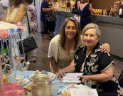
Pictured, WHWC President, Rachel Garcia (left) with Fundraising Chair, Freddie Ferguson

As you know are aware, we just held our 9th Annual Summertime Tea.
I thank all of you who participated by spending many hours preparing for the event . . . the basket makers, table decorators, our new & successful Wine Pull, bar, ticker sellers, Invitations and Program makers! Everyone did a lovely job!! Altogether, this was our most successful Tea fundraiser to date.

November 4 is the date for our annual Holiday Boutique and Bake Sale! It’s being held at the Woodland Hills Presbyterian church at Platt & Hatteras from 9AM until 3PM.


PUBLICITY/SOCIAL MEDIA – Jana Huntley
If you’re on Facebook & haven’t “friended” WHWC, FRIEND US! There’s lots to see !!!!

LEGISLATION – Rosadel McClure, Legislation Chair
The summer issue of the GFWC/CFWC CALIFORNIA CLUBWOMAN contains valuable information for our club to consider in the focus of our charities.
A very informative article by Colleen Jansen recaps the recent Report on the Status of Women and Girls in California from Mount Saint Mary’s University.
“The big change is the lack of change …… There is some good news, but no sign of changing the wage gap for California women …... They still earn 88 cents for every dollar that a man makes.”
“The pandemic impacted women’s health due to the delay in healthcare, mental health, and depression.”
“Flex/remote work was positive for men’s careers by 57%. The opposite result for women was a negative impact of 30%.”
To read more the entire article is in the GFWC/CFWC CLUBWOMAN Magazine on the CFWC website.

VETERANS AFFAIRS - Rosadel McClure, Veterans Chair

At the WHWC May meeting, dedicated to honoring our country’s Veterans, everyone remembers Ethel Margolin, the spunky almost 101-year-old veteran, who was present and spoke. On the Fourth of July, Ethel was honored to throw out the first ball at Dodger Stadium.

At the opening of the meeting, we were privileged to hear Jimmy Weldon present his dedication of the American Flag. Sadly Jimmy Weldon passed July 7, 2023, just short of his 100th birthday.
In memory of Jimmy, here are excerpts from his famous “I Am the Flag” that Jimmy recited before the Pledge of Allegiance. You can access him reciting this at: https://youtu.be/0w-b5s64sCk
I am the flag of the United States of America,
I rode with Ethan Allen and the Green Mountain Boys at the Battle of Fort Bennington and blazed the trail with Davy Crockett and Daniel Boone.
I galloped up the slope of San Juan Hill with Colonel Teddy Roosevelt and his Rough Riders and was carried through the Halls of Montezuma to the shore of Tripoli by the United States Marine Corps. History will never write my obituary, for I am the Stars and Stripes forever.
I am Old Glory. I am your flag. I am YOU!

 Cheryl Ayers, Chair
Thursday, September 28 @ 11:30AM
Join the WHWC Lunch Bunch at BARNEY’S GOURMET BURGERS
4799 Commons Way, Calabasas, CA 91302.
In the Northeast corner of the Commons Shopping Center, next to King’s Fish House.
We have a great time socializing. Order off the menu - separate checks will be provided
Please RSVP if you even think you will attend so that enough
spaces for seating us together will be available.
CHERYL: Landline 818/884-9313 home Cell/Text 818/317-2685 cell and texts cheryllcornell@yahoo.com

BON APPETIT – Arlene Bell
A LOVELY “BON APPETIT” luncheon last June at Perin Lal’s gorgeous home. And, the food … an amazing Indian feast!! Contact Arlene Bell if you’re interested in joining “Bon Appetit” in the coming year.
Arlene CELL/Text 818/963-0062 filmboss1@aol.com

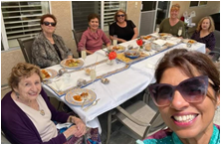

 BOOK CLUB is back! – Betty Paravato
Our wonderful Book Club is thriving! If you want to join contact Betty. Following is the Schedule of upcoming meetings:

September – Kay Winert
October – NO MEETING (Betty is out of town)
November – Karen Lakin (Karen has already bought the book -- contact her for a copy)
December – Rosadel McClure
January – Eileen Gouse
February – Cathy Stewart

If you are interested in holding a meeting at your home after February, please let Betty know. Your responsibility as hostess is to be the discussion leader on the book you chose and to provide refreshments. All WHWC members are welcome! Hope to see you!
BETTY Landline 818/716-6299 Cell 818/625-0545 bparavato@socal.rr.com


GFWC National Day of Service to End Hunger in the United States occurs during the month of September. GFWC is asking all clubs to do something to help end hunger in America by giving food to their local food pantries. If each member would contribute one or more non-perishable food items at our September 21 meeting, it will certainly have an impact!
(The WVFP desperately needs cans of soup with pull-top tabs.)


LOAVES & FISHES PANTRY - GUADALUPE CTR – Mary Escherich
The Loaves and Fishes Pantry at the Guadalupe Center has a critical shortage of food. While our club generously gives to the Woodland Hills Food Pantry, this is another food pantry at the GUADALUPE CENTER that is in danger of having to close because of lack of donations and an increase in families needing help. If you can help out at all with items like canned fruits, canned soups, peanut butter, mac & cheese or dry cereals, please call Call/Text Mary Escherich at 818/439-1312. . Also, gift cards to Smart and Final, Vons and Vallarta would be welcome.

FAMILY RESCUE MISSION, Canoga Park
In August, Arlene Bell and Betty Paravato, worked at the FAMILY RESCUE MISSION in Canoga Park to prepare and fill 685 backpacks that were distributed to the families registered at the mission. Each backpack was filled with the supplies needed before the students head off to school!
Donated backpacks were filled with materials for grades K through 12 -- using cute backpacks for the little ones and more solid colors for the upper grades. Supplies included writing paper, notebooks, pencils, pens, crayons, markers, tape, glue sticks, and folders. Texas Instrument calculators were provided for the upper grades. All materials were donated by local merchants, churches, and the public.
On giveaway day, the families lined up at the Center (even hours before we were ready to give out the backpacks). Each family drove in, and they were asked what grades and sex were needed for the occupants of the vehicle. Then, a runner would come into the hall to grab the appropriate backpack(s). In addition to the backpacks, manufacturers had donated clothing, socks and shoes that were also given out to each car.
It was a lot of hard work, but so rewarding. Maybe next year other members would like to volunteer for this project? You’ll hear more about it next summer!

TEACHER SUPPLIES GIVEN TO 2 LOCAL SCHOOLS
Some of our members solicited items from local stores to help provide needed supplies for the teachers at two elementary schools in our area. Boxes of supplies such as reams of paper, pencils, pens, markers, sharpies, dry erase markers and small dry erase boards, notebooks, erasers, staples, and crayons were taken to Pomelo Elementary Charter School and St. Bernardine’s Elementary School. This was a dream-come-true for these schools as budgets are very tight right now and what the teachers are allowed to spend is very limited. In all, over $400 in supplies were donated. A big thank you goes out to Office Depot and Staples along with the Dollar Store and 99-Cent Store for their donations. Members also purchased items to fill the supply list adding in-kind donations of $75.

SUPPORT NEEDED FOR OUR DISTRICT PRESIDENT, BETTY!
Please plan on attending the Area C meeting on Saturday, October 14. We have a bus (courtesy of Councilman Bob Blumenfield) that will pick us up at the Ralph’s Shopping Center on Sherman Way and Shoup Ave. The bus will leave promptly at 8AM. Anyone needing a ride to the bus stop, please call Arlene Bell at 818/963-0062 or Betty Paravato at 818/625-0545. Cost is $40 per person and needs to be paid no later than our September meeting. It will be an all-day event with speakers, workshops, and vendors. Bus will return back by 3:00 p.m.

SIERRA-CAHUENGA DISTRICT MEETING . . . SAVE THE DATE!

Plan to join a carpool & head to Lake Hughes . . . to one of the cherished charities our WHWC supports! You know . . . all of the pillows we cut out and are sewn into the darling pillows each camper receives! Our first District meeting after our summer hiatis will be held at The Painted Turtle Camp. SAVE THE DATE: MONDAY, SEPTEMBER 18. We all want to support the District’s President, too . . . our very own Betty Paravato! https://www.thepaintedturtle.org/

FREE THE GIRLS – BARBARA HOGAN
100 bras collected at WHWC meetings were dropped off in early June at the HANES Store in the Camarillo Outlet Mall for “FREE THE GIRLS”. Educate yourself about this extremely worthwhile organization at https://www.freethegirls.org/ (From their website: Maybe you have one or a few bras in your drawer that you don’t wear? We accept new and gently-used bras in good condition. Bras and the second-hand clothing market provide a safe and powerful economic opportuity for survivors of trafficking in the developing countries we serve. A woman only has to sell 4 bras a day to earn a livable wage).
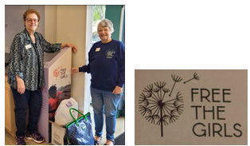

CASA PACIFICA FOSTER CHILDREN – BETTY PARAVATO
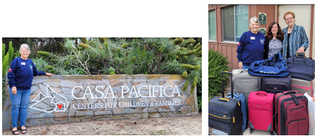
In early June, Chris Roper and I visited Casa Pacifica in Camarillo. We delivered 14 suitcases for the kids (ages 12 to 18) to be used when going to foster homes (instead of garbage bags). The facilitator mentioned that they are low on suitcases . . . so our timing was perfect! They were so thrilled to receive what we brought! So, if any of you are planning trips and think that perhaps your luggage needs to be updated, consider bringing your old suitcases (any size) to the club meeting. Suitcases just must be in decent shape (not perfect) with the zippers, handles and wheels all in working order


Last June, WHWC members, Chris, Betty, Jana, Cheryl A., Arlene & Rosadel, enjoyed a spectacular evening attending LuskinOIC’s Annual Gala at Universal Studios
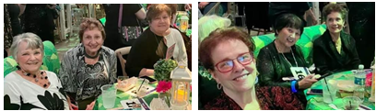

 WE GOT MAIL!
Center for Assault Treatment Services (CATS) for our monetary contribution in memory of beloved member, Marilyn Yelvingon
California Wildlife Center for our monetary contribution
Casa Pacifica Centers for Children & Families for our donation of new and used suitcases
Angels Way for our Club’s support of their Annual Gala Breakfast
Sisters of the Holy Cross for our in-kind donation of US & foreign canceled stamps

FROM ROSADEL McCLURE . . . To all my sister members
My heartfelt appreciation for your letters, cards, and calls of caring and concern. You have helped sustain me during this difficult and lingering time.
Hopefully I will be able to remain vertical and see you all at our September Anniversary meeting.

DATES TO KEEP ON YOUR RADAR!

Monday, September 18 – DISTRICT MEETING @ PAINTED TURTLE CAMP

Thursday, September 21 – WHWC Monthly Meeting

Saturday, OCTOBER 14, 10AM-3PM – AREA C CONFERENCE, The GRAND, Long Beach

Saturday, NOVEMBER 4, 9AM-3PM – CHRISTMAS BOUTIQUE & BAKE SALE @ Woodland Hills Presbyterian Church (Platt & Hatteras)

Friday, April 12, 2024 – SIERRA-CAHUENGA DISTRICT CONVENTION

May 16, 17 & 18, 2024 – GFWC CALIFORNIA STATE CONVENTION in Northern California

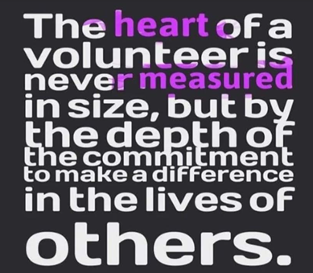

KUDOS TO ALL WHO VOLUNTEERED COUNTLESS HOURS IN PREPARATION FOR OUR 9TH ANNUAL “SUMERTIME TEA” . . . especially the members who decorated the 23 tables: Cheryl Ayers, Cary Bird, Irene Deak, Mary Escherich/Paula Hayes, Freddie Ferguson, Rachel Garcia, Debbie Hartzman, Jana Huntley/Traci Huntley, Karen Lakin/Liz Strother, Roberta Marlowe, Betty Paravato, Chris Wright Roper, Cheri Steelman, Cheryl Sullivan, Ruthanne Thompson, Jeanne Wiedmeier, and the “Red Hatters” in memory of Marilyn Yelvington!



